

iVMS-4200
Intelligent Video Management System
User Manual

Hangzhou Hikvision Digital Technology Co., Ltd.

Notices

The information in this documentation is subject to change without notice and does not represent any commitment on behalf of HIKVISION. HIKVISION disclaims any liability whatsoever for incorrect data that may appear in this documentation. The product(s) described in this documentation are furnished subject to a license and may only be used in accordance with the terms and conditions of such license.

Copyright © 2006-2010 by HIKVISION. All rights reserved.

This documentation is issued in strict confidence and is to be used only for the purposes for which it is supplied. It may not be reproduced in whole or in part, in any form, or by any means or be used for any other purpose without prior written consent of HIKVISION and then only on the condition that this notice is included in any such reproduction. No information as to the contents or subject matter of this documentation, or any part thereof, or arising directly or indirectly therefrom, shall be given orally or in writing or shall be communicated in any manner whatsoever to any third party being an individual, firm, or company or any employee thereof without the prior written consent of HIKVISION. Use of this product is subject to acceptance of the HIKVISION agreement required to use this product. HIKVISION reserves the right to make changes to its products as circumstances may warrant, without notice.

This documentation is provided “as-is,” without warranty of any kind.

Please send any comments regarding the documentation to:
overseabusiness@hikvision.com

Find out more about HIKVISION at www.hikvision.com

Contents

Notices 1
Contents 1
1. Overview 2
1.1 Features & Functions 2
2. Update Info 4
3. Start iVMS-4200 5
3.1 User Registration 5
3.2 Add Device Wizard 5
3.3 User Login 7
3.4 Control Panel Introduction 8
3.5 User Management 9
4. Stream Management 12
4.1 Add Device 12
4.2 Add a Stream Media Server 14
4.3 Add a group 15
5. Live View & Control 17
5.1 Main View Components 17
5.2 Start Live View 19
5.3 Live View Snapshot 20
5.4 PTZ Control 20
5.4.1 Preset 21
5.4.2 Pattern 22
5.4.3 Patrol 23
5.5 Alarm & Event View 24
6. Recording 26
6.1 Local Recording 26
6.2 NVR Recording 26
6.2.2 Add NVR Server 26
6.2.3 NVR Recording Schedule Setup 28
6.3 Remote Recording 30
7. Playback 33
7.1 Local Playback 33
7.2 Instant Playback 34
7.3 Event Playback 35
8. Backup 38
8.1 Backup Snapshot 38
8.2 Backup Video Clips 40
9. Stream & Device Configuration 41
9.1 Stream Configuration 41
9.1.1 Picture 42
9.1.2 Quality 43
9.1.3 Schedule 44
9.1.4 Display 45
9.1.5 Motion 46
9.1.6 Tampering 48
9.1.7 Video Loss 49
9.1.8 PTZ 50
9.1.9 Connection 51
9.2 Device Configuration 52
9.2.1 Status 52
9.2.2 General 53
9.2.3 Channels 53
9.2.4 Network 54
9.2.5 Alarm 55
9.2.6 User 57
9.2.7 HDD 59
9.2.8 Exception 60
9.2.9 Files 61
9.2.10 Log 62
9.2.11 Other 62
Chapter 10 E-Map 64
10.1 Add E-Map 65
10.2 Edit E-Map 66
10.3 Delete E-Map 67
Chapter 11 Hardware decoding 68
11.1 Add hardware decoder 68
11.2 Edit TV Wall 69
11.3 Add streams into TV wall 73
Chapter 12 Log 75
12.1 Log query 75
12.2 Export Log 75
13. System Configuration 76
13.1 General 76
13.2 File 76
13.3 Alarm Sound 77
13.4 Email 77
14. FAQ 79
14.1 Live View 79
14.2 Recording 79
14.3 Playback 79
14.4 Configuration 80

1. Overview

iVMS-4200 intelligent video management system is a newly-developed colligation software which includes not only NVR, DVR, and IP camera management but also compression card, decoder connection and setup. The powerful functions make it popular in local & remote surveillance of supermarkets, stores, districts and residential places, etc.
This user manual describes the function, configuration and operation steps of iVMS-4200 software. To ensure the properness and stability of the software, please kindly refer to the contents below and read the manual carefully before installation and operation. This user manual can be acquired via your supplier.

1.1 Features & Functions
V1.00.00
- The software contains 5 subsystems: User Client, PC NVR Server, Stream Media Server, Decoder Sever, and Encoder Server.
- Main View: View live and instant video playback; and various video operations such as picture capture, recording, PTZ control, etc are supported.
- E-Map: Manage and display E-Map and hot spots; operate map zoom in/out, view hot spot, display alarm, and other E-Map operations are supported.
- Event Search: Search and playback of the event record files.
- TV Wall View: Configure and operate TV wall for video decoders.
- Stream Import: Add, modify and delete groups and all kinds of stream from Hikvision devices.
- Local Log Search: Search, view and backup different sorts of local logs such as alarm, operation, system logs, etc.
- User Management: Add, modify and delete the user of Ivms-4200; assign operating permissions to each user.
- Device Management: Add, delete, and configure parameters of Hikvision devices, such as network settings, alarm in/out, hard disk management and upgrade, etc.
- NVR Management: Add, modify and delete the storage server; configure parameters (e.g., record schedule, network, HDD, etc.) for the added storage server.
- Stream Media Servers: Add, modify and delete the stream media server; configure parameters (e.g., RTSP port, port upper/lower limit, etc.) for the added stream media server.
- Decoder Server: Add, modify and delete the decoder; configure parameters (e.g., network, alarm input/output, exception, etc.) for the added decoder.
- Stream Configure: Configure stream parameters (e.g., image quality, record schedule, motion detection, etc.).
- System Configuration: Configure the general settings of iVMS-4200, such as the saving path of captured images, recordings, alarm sound settings and email setup.

2. Update Info

* This chapter is reserved for future updating information of software upgrading.

3. Start iVMS-4200
Click iVMS-4200 to start the software.

3.1 User Registration
For the first time to use the iVMS-4200 software, user needs to register an administrator for login.
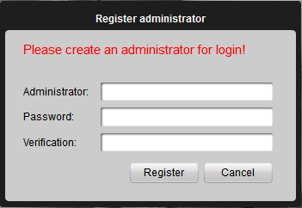
Input the administrator, password and verification in the dialog box and click Register. Then, user can log in as the administrator.
Note: Enter, Space, and TAB buttons are invalid for the user name and password. The password cannot be null, and should not contain the following characters, including “%” and “’”. Password should not be less than six characters and does not support the copy and paste operation.

3.2 Add Device Wizard
After registration and login, the following information will pop up:
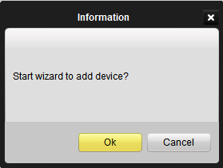
Click OK to start the wizard and add the device, or click Cancel to exit the wizard.
Step1: According to the hint, click import stream to enter the stream import control interface.
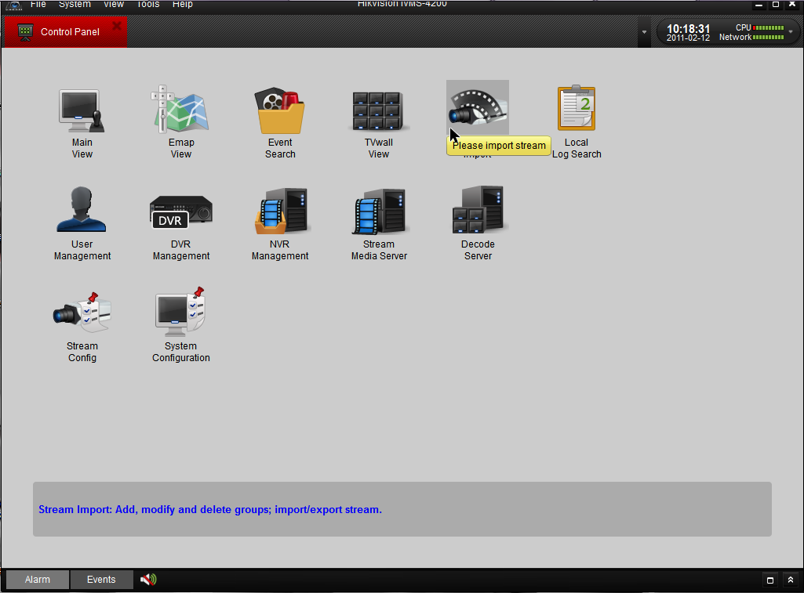
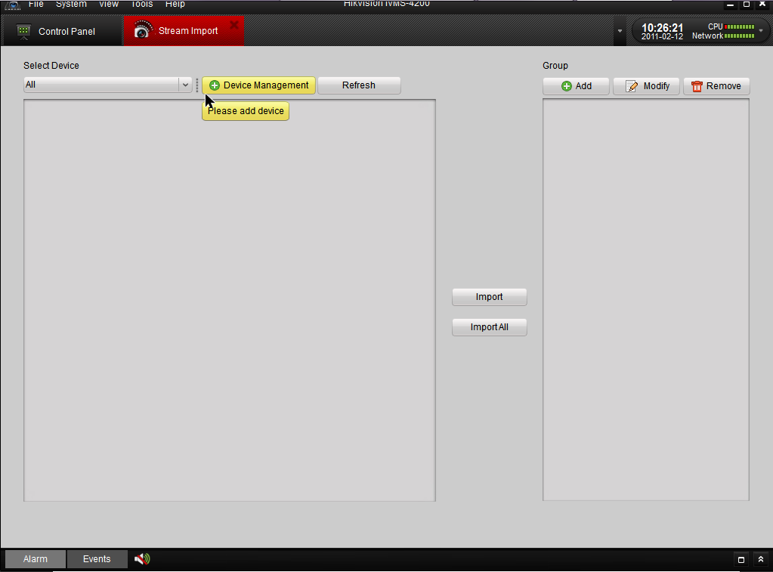
Step2: According to the hint, Click Device Management to popup the device management interface and then click Add to enter the device information in the dialog box of Add Device interface.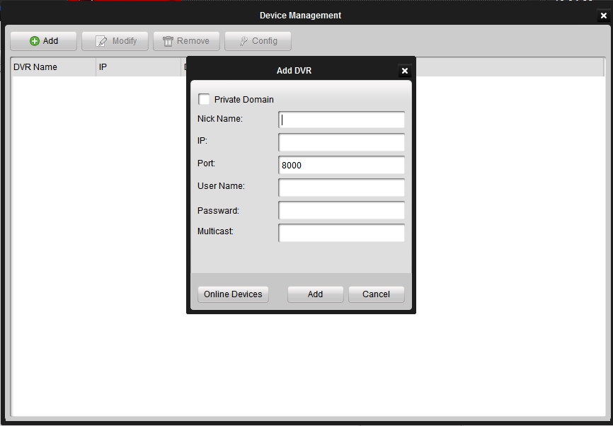

3.3 User Login
When user opens the iVMS-4200 software after registration, the login dialog box will pop up, shown as below:
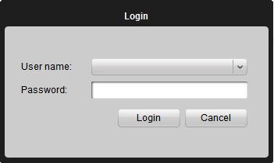
Input user name and password, and then click Login to start using the iVMS-4200 software.

3.4 Control Panel Introduction
For the intelligent video management system, Hikvision iVMS-4200 provides an effective and convenient GUI for user to operate the client software. The main control panel of the iVMS-4200 is showing as follow:

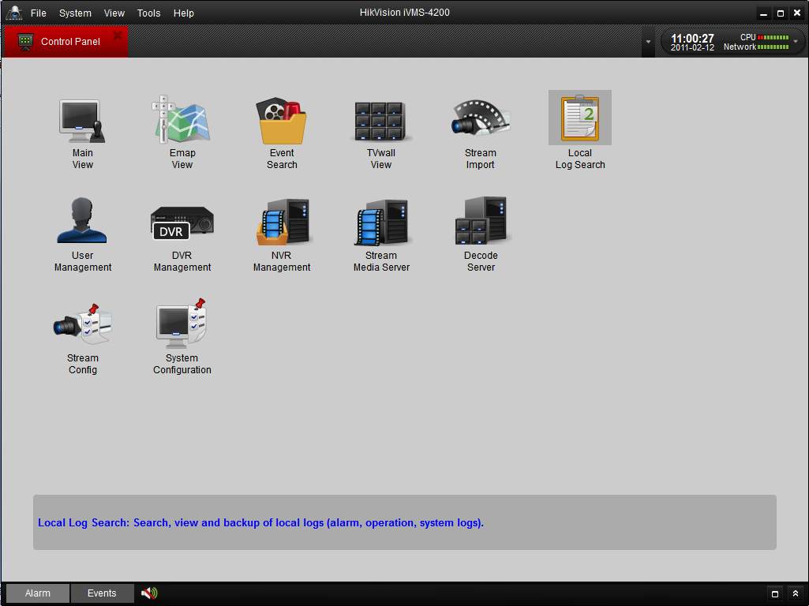

The control panel includes13 icons, the function of icons are described as below:

Control Panel Description:
Menu | Description
Main View | View live and playback video; realize video operation (e.g., picture capture, recording, PTZ control, etc.).
E-Map View | Manage and display E-Map and hot spots; realize E-Map operation (e.g., operate map zoom in/out, view hot spot, display alarm, etc.)
Event Search | Search and playback of the event record files; realize playback operation.
TV Wall View | Configure and operate TV wall.
User Management | Add, modify and delete the user; assign operating permission to each user.
System Option | Configure the general parameters, saving path of files, alarm sound, Email, etc.
Stream Import | Add, modify and delete groups; import/export of stream.
Stream Config | Configure stream parameters (e.g., image quality, record schedule, motion detection, etc.).
DVR Management | Add, modify and delete DVR device; configure parameters (e.g., network, alarm input/output, HDD, etc.) for the added DVR.
NVR Management | Add, modify and delete the storage server; configure parameters (e.g., record schedule, network, HDD, etc.) for the added storage server.
Stream Media Servers | Add, modify and delete the stream media server; configure parameters (e.g., RTSP port, port upper/lower limit, etc.) for the added stream media server.
Hardware Decoders | Add, modify and delete the decoder; configure parameters (e.g., network, alarm input/output, exception, etc.) for the added decoder.
Local Log Search | Local Log Search: Search, view and backup of local logs (alarm, operation, system logs).

3.5 User Management

Click  to enter the following user management interface.

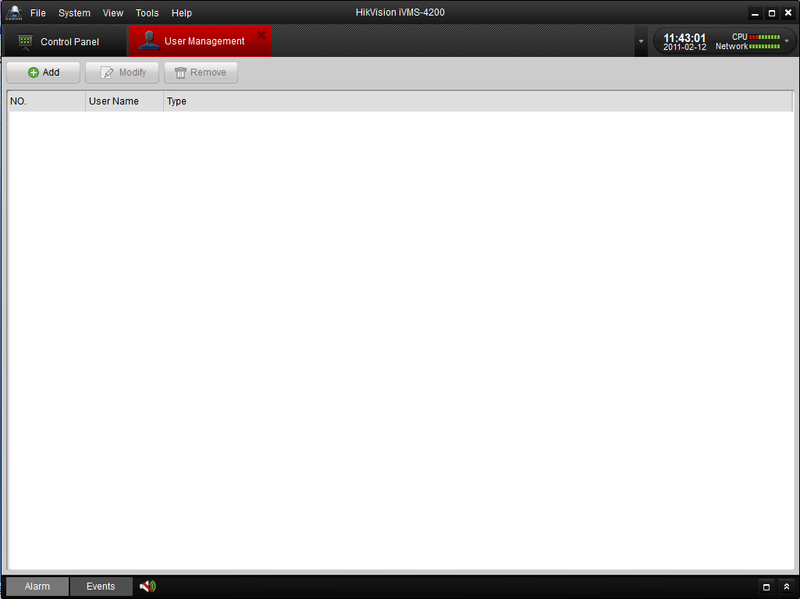
Click Add to popup the Add User dialog box as followed:

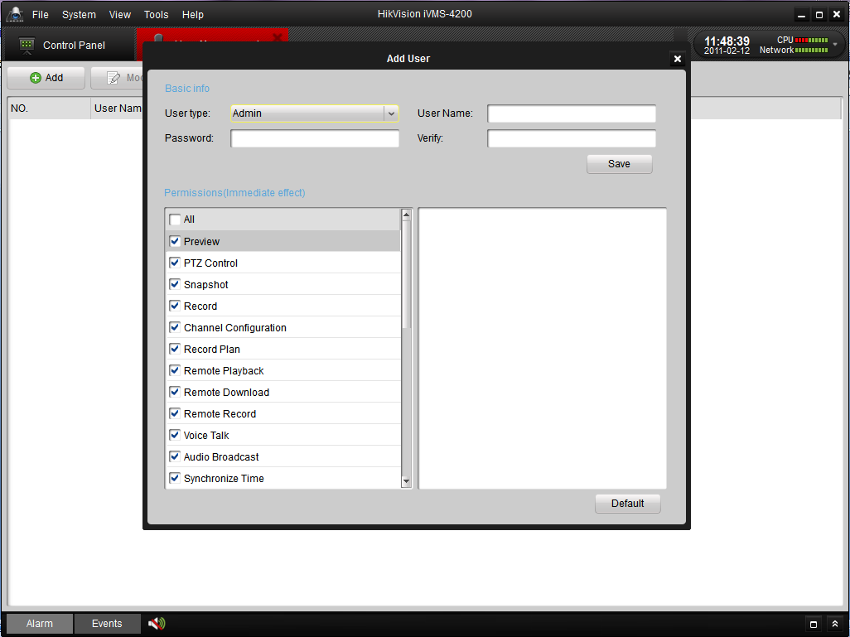

For the user management, the dialog box of add user settings include two parts: Basic Information and Permissions.

Basic Information—provides two kinds of user types (Administrator and Operator) to support the users have different permissions.
Permissions—include 26 optional permissions and provide manual selected permission function for the different users.

Tips: Admin user has default all permissions and operator user’s permission should be selected from list. All selected permissions will be immediate effect.

Input user name and password, and then click Save to add a new user. Click Modify to change the password and permissions.
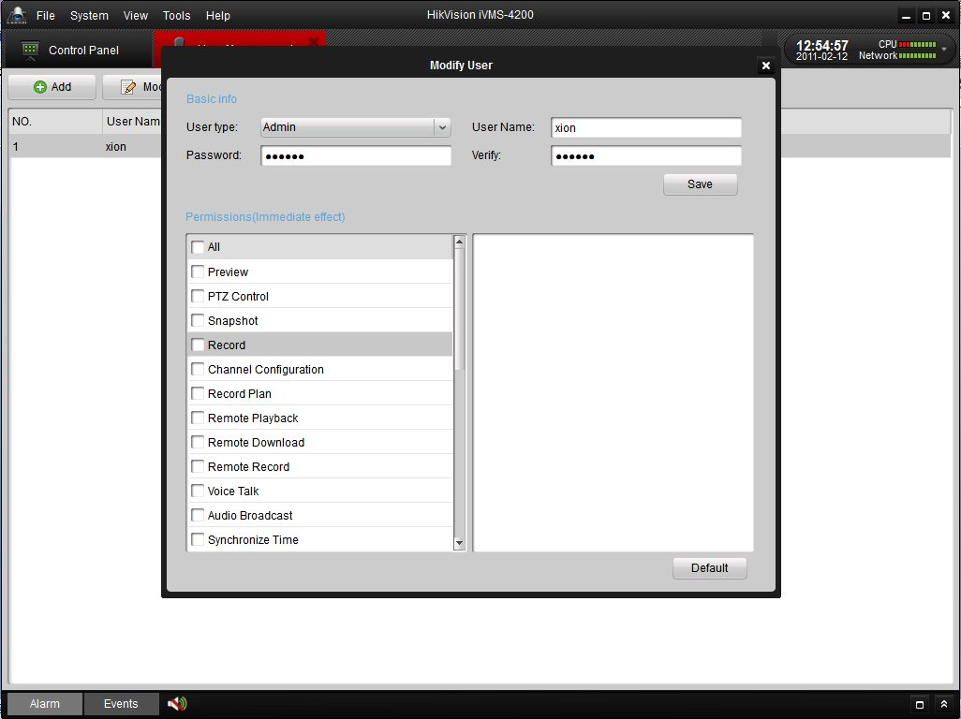
After having modify user’s settings, click Save to keep it. And click to go back User Management interface. Click Remove to delete user.

4. Stream Management

Before any operations, users need to add a device and configure it. Click 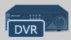 to enter the device configure mode, and then click Add to manage the device.

4.1 Add Device

iVMS-4200 is able to automatically search all the on-line devices within the same gateway. You can add a device either by selecting the listed online device or by manually inputting the name, IP address, port, user name and port of the device (Figure3-6).

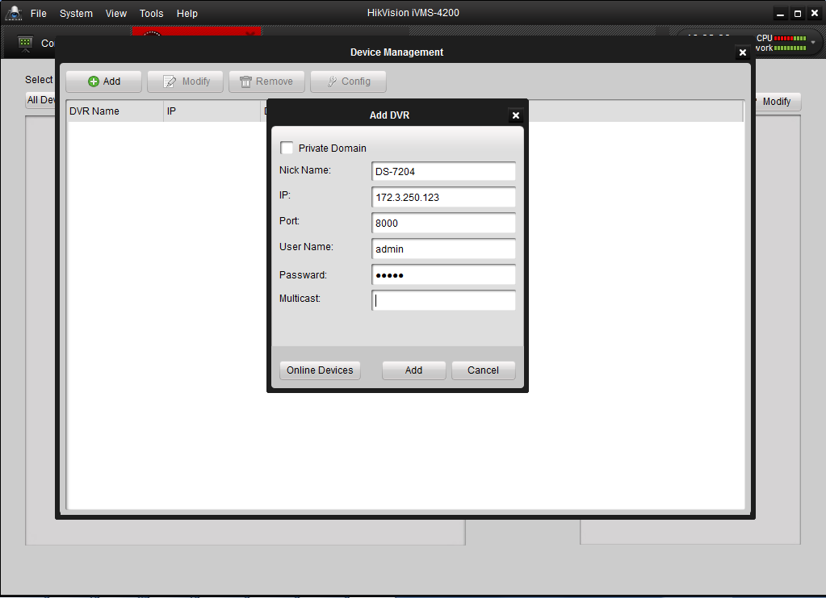
Figure 3-6 DVR Management - Add DVR

After added the device according to the above steps, click Config to enter the Device Parameters configuration interface (Figure 3-7). User is allowed to view and configure the following settings: Status, General, Channels, Network, Alarm, User, HDD, Exception, Files, Log and Other.
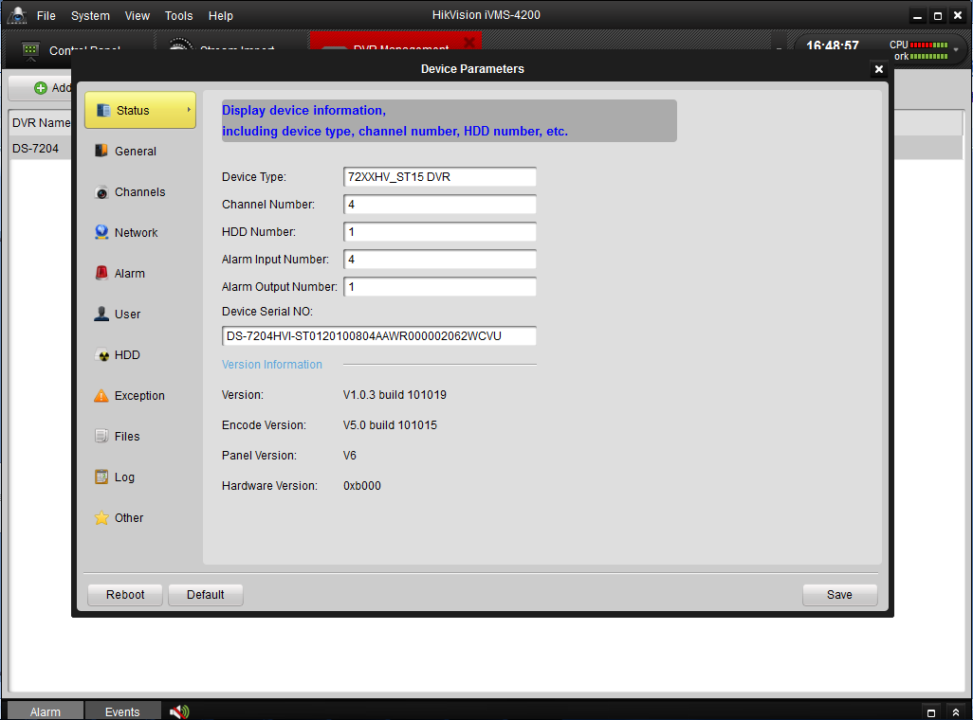
Figure 3-7 Device Parameters
Settings Menu of DVR Management:
Menu | Description
Status | Display device information, including device type, channel number, HDD number, etc.
General | Configure general parameters of device (e.g., device name, device No., etc.).
Channels | Configure channel parameters of device (e.g., enable/disable analog camera, add/modify/delete IP camera, etc.).
Network | Configure network parameters (e.g., IP address, port, Email, etc.).
Alarm | Configure alarm input/output parameters (e.g., alarm input name, alarm input triggering method, alarm arming schedule and actions, etc.).
User | Add, modify and delete the user; assign operating permission to each user.
HDD | Configure HDD parameters; add, modify, delete and format the HDD.
Exception | Configure exception parameters of the device, and set alarm linking method for each exception type.
Files | Search, play and remotely back up the record files of device.
Log | Search and view logs.
Other | Configure other parameters (e.g., RS-232, remote upgrade, etc.).

Go back to the device management interface, click modify to change the device information, and Click remove to delete the device.

4.2 Add a Stream Media Server
Click 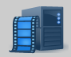 to enter the Stream Media Server configuration interface. And then click Add, the configure dialog box will popup as followed.
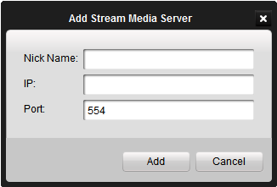
Input the Nike Name, IP address and Port (The Port: 554 is the default RTSP number), and then click Add to keep it.

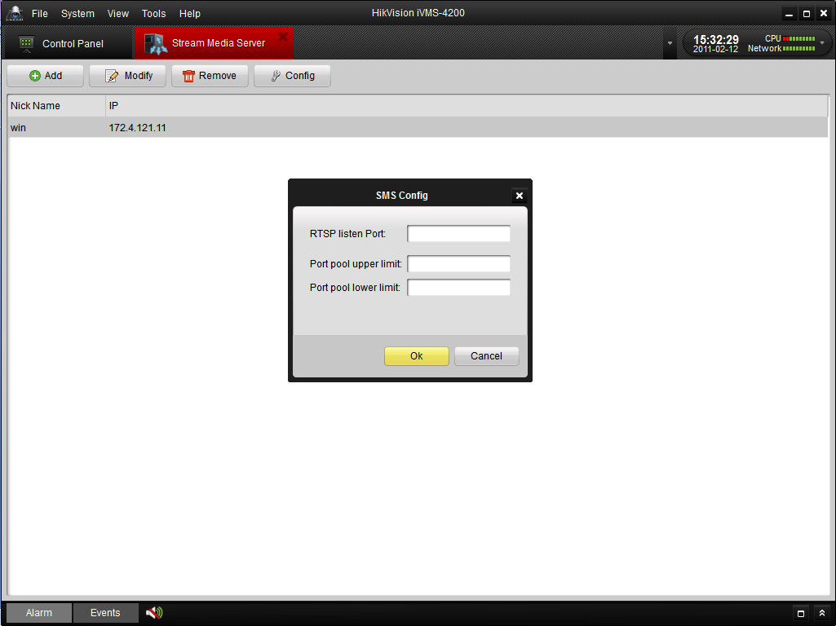

Click Modify to change the Nick Name and IP address.
Click Remove to delete the Stream Media Server.
Click Config to configure the SMS with RTSP Listen port, Port pool upper limit and Port pool lower limit.

4.3 Add a group

After adding the target device, please return to the control panel interface and click Stream Import to enter camera group configuration interface (Figure 3-8).And then click Add to create a group in the right area (Figure 3-8, Figure 3-9). Select the camera in the left area, and then click import or import all to add the cameras to the group.
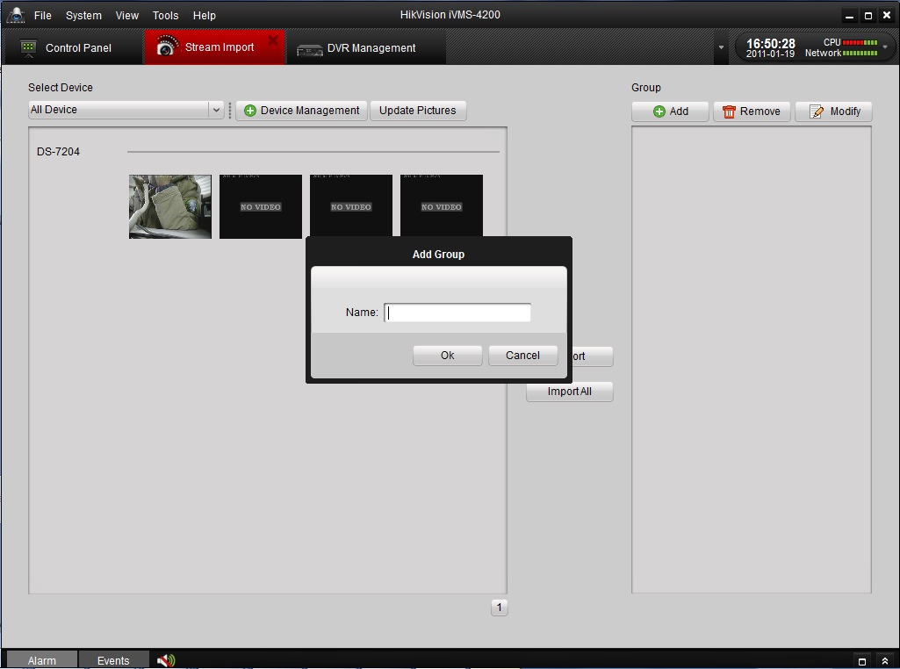
Figure 3-8 Stream Import - Add a Group
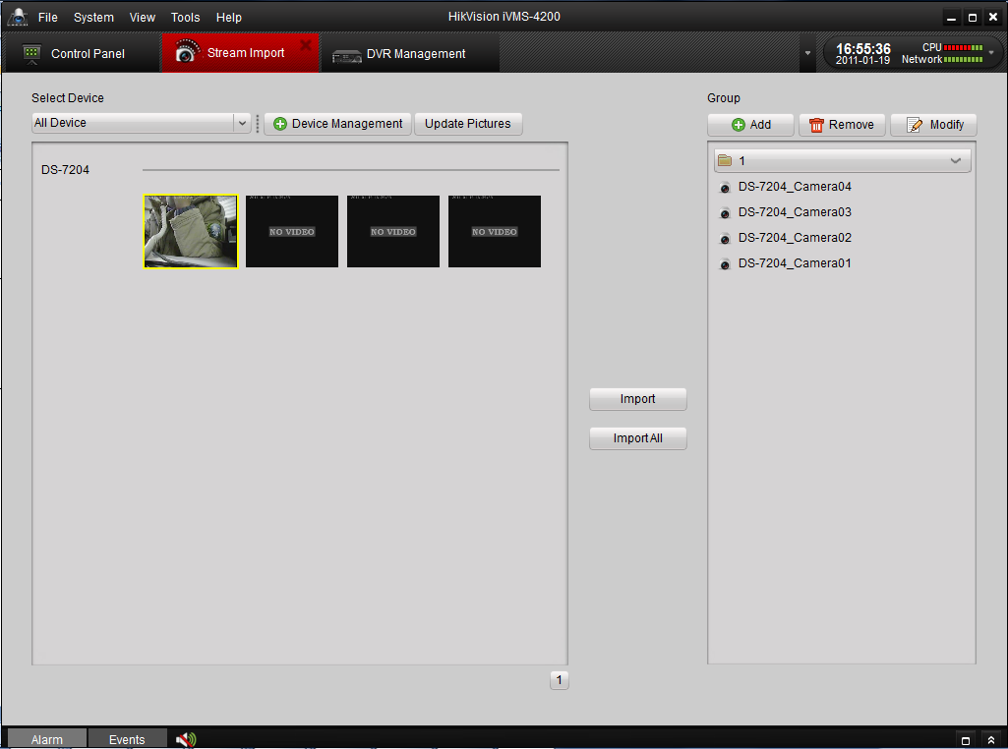
Figure 3-9 Stream Import -Done
Click Remove to delete the group.
Click Modify to modify the group number and camera’s information in the group.

5. Live View & Control
[Notice]
A camera group is required to be defined before live view. For the group operation, please kindly refer to the last chapter.

5.1 Main View Components
To start live view, please click the icon ‘Main View’ of the control panel, or go to ‘View’ -> ‘Main View’ on the tool bar.

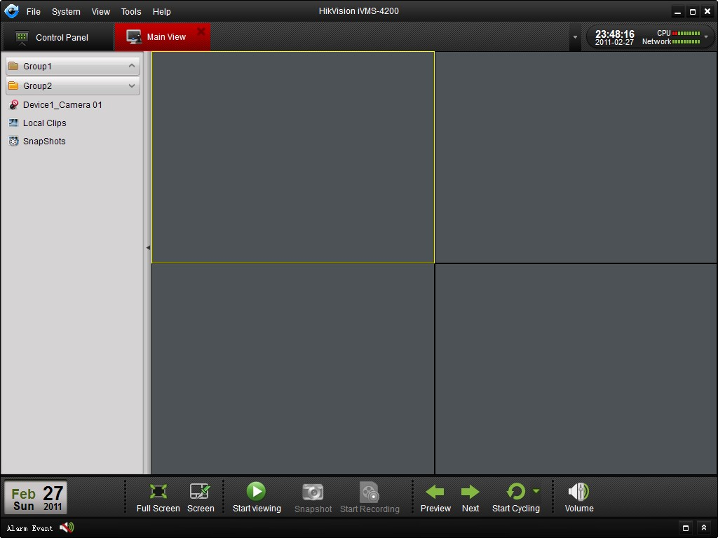
Figure 5-1 Main View

Icons in the camera list:
Icon | Description
 | Camera is connected and works normally
 | Camera is not connected
 | Camera is recording
 | Stop recording

Main View Buttons:
Button | Name | Description
 | Layout | Select different layout mode
 | Full Screen | Display video in full screen mode, click again to restore
 | Close All | Stop the display of all cameras
 | Manual Record | Start manual record for the corresponding cameras, click again to stop
 | Manual Switch | Click to view previous and next camera
 | Auto Switch | Start auto switch by cameras or by groups
 | Volume | Adjust the volume for live audio
 | Live Audio | Enable/disable live audio

5.2 Start Live View
To preview the live video, drag the camera in left list to the right display window (Figure 5-2).
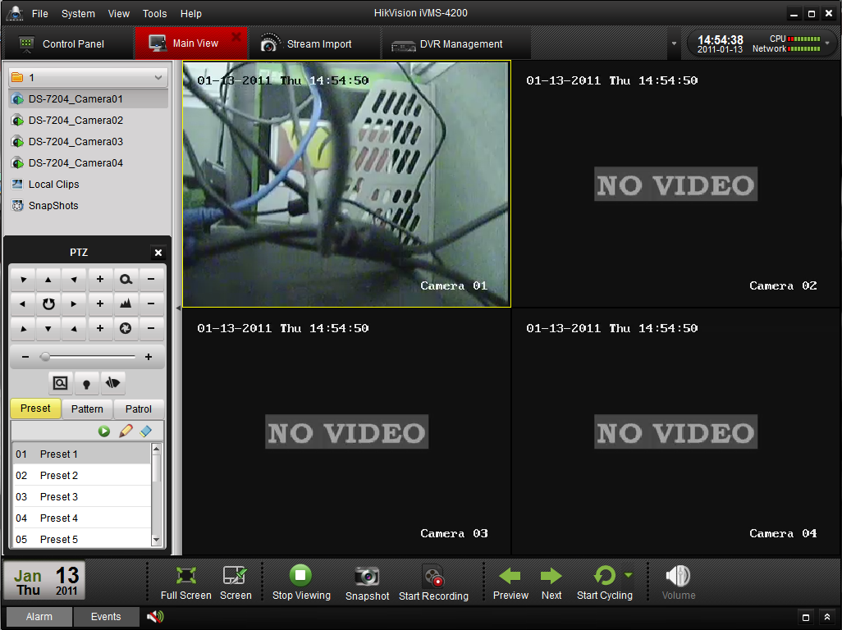
Figure 5-2 Start Live View
Tool bar in each display window:
Button | Description
 | Take a snapshot of the camera
 | Start manual record, click again to stop.
 | Start voice talk, click again to stop
 | PTZ control, 8 direction icons will be displayed on the video.
 | Check the input stream status
 | Go back to the stream configuration interface
 | Stop live view
 | Instant playback about 7 minutes record of current camera
 | Audio button, click to open and close

5.3 Live View Snapshot
To get the snapshot of a live view camera, single click on the camera image to select that display window, and then click icon on the bottom tool bar of Main view, or click icon in the tool bar of this display window. A hint message will be displayed to remind the users if the snapshot is successful or not. If the snapshot is successful, there will be a link to the snapshot restoring path; and if the snapshot failed, there will be error messages accordingly.

5.4 PTZ Control
Notice: Users are required to input correct PTZ setting parameters in the PTZ configuration page before they can get control of the PTZ. Please refer to Section 9.1.8 for detail of PTZ configuration.
For the PTZ control, click the icon on the tool bar of the display window, and the PTZ control panel will be displayed on the left side of the Main View (Figure 5-3).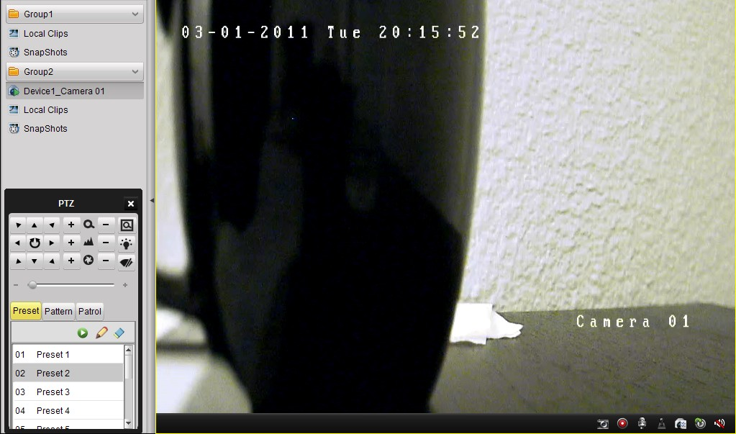
Figure 5-3 PTZ Control
There will be 8 directional buttons (up, down, left, right, upper left, upper right, bottom left, bottom right) on the display window when the mouse is located in the relative positions. Click on those directional buttons to control the PT function, or click the directional buttons on the PTZ control panel.
Button Description for the PTZ Control Panel:
Button | Description
 | Zoom
 | Focus
 | Iris
 | Full-scale
 | Light
 | Wiper
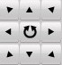 | Directional buttons, click to start/stop auto scan.
 | Speed adjustment for PT function
 | Preset configuration
 | Pattern configuration
 | Patrol configuration
 | Go to
 | Edit
 | Delete

5.4.1 Preset
To add a preset for the PTZ, click the directional buttons and control the PTZ to a desired location, select a PTZ preset number from the preset list, and then click and name this PTZ preset (Figure 5-4). To delete a preset, select the PTZ preset from the preset list, and then click to remove it.
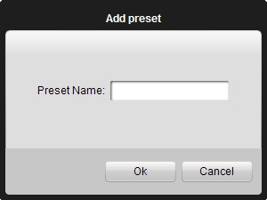
Figure 5-4 PTZ Preset

5.4.2 Pattern
To add a pattern for the PTZ, click the button to enter the PTZ pattern path setup panel (Figure 5-5). Select a PTZ pattern path number from the pattern list, click to enter edit mode, and click to start recording of this pattern path. Use the directional buttons to control the PTZ movement and click to stop pattern recording. Click to save the pattern path.
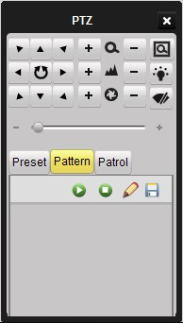
Figure 5-5 PTZ Pattern

5.4.3 Patrol
To add a patrol path for the PTZ, click the button to enter the PTZ patrol path setup panel (Figure 5-6). Select a track number from the list, and click to add a preset (also defines the dwell time and PTZ speed for that preset) for this patrol path (Figure 5-7). Click to call the patrol path and click to stop calling. Click to edit a preset in the patrol path.
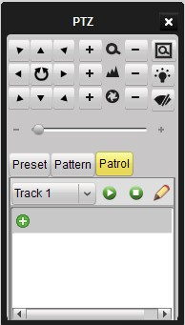
Figure 5-6 Patrol
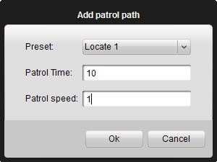
Figure 5-7 Add preset to patrol path

5.5 Alarm & Event View
In the main view interface, there is an “Alarm Event” viewer (Figure 5-8). Click icon to view the alarm event list in the main view window (Figure 5-9), and click icon to maximize the alarm event interface and display it in a new Tab page of the whole software interface.
In the alarm event viewing window, there are 4 different types of alarm event: “Motion”, “Video abnormal”, “Alarm input” and “Device abnormal”. Select one or multiple events to view relative log report (Figure 5-9).
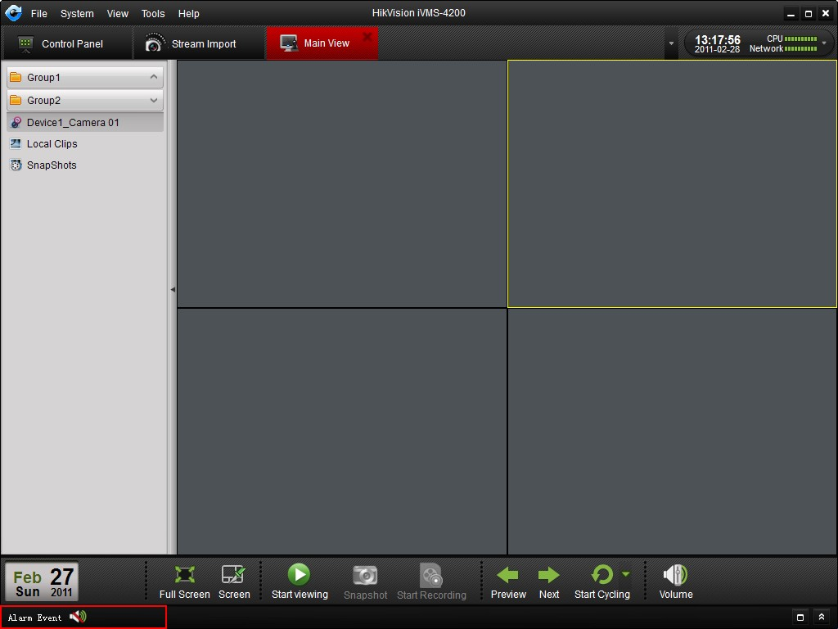
Figure 5-8 Alarm Event
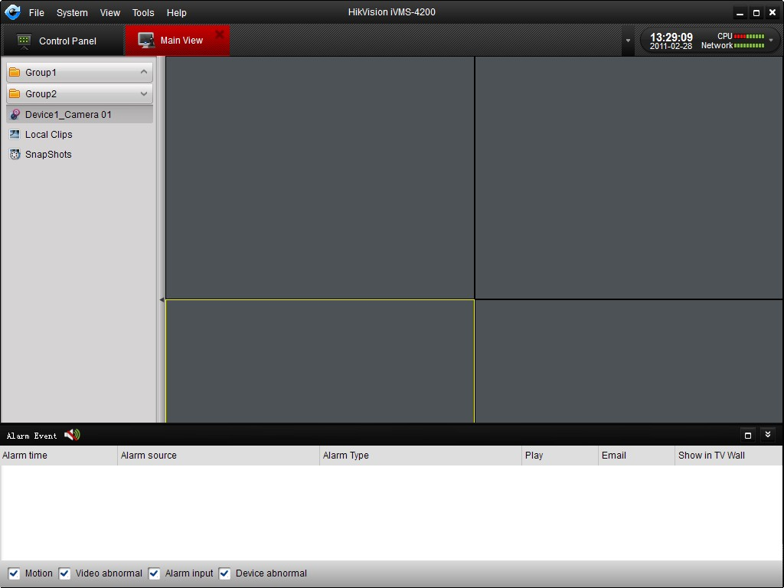
Figure 5-9 Alarm Event Display Window

6. Recording
iVMS-4200 software provides two main recording modes: Local Recording, NVR Recording & Remote Recording.

6.1 Local Recording
Local Recording (also known as Manual Recording) function allows you to record the live video instantly while in the Main View mode. Please take the following steps to start local recording:
- Select a channel in the group and double to view the live video.
- Then click 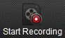 button at the bottom of main view panel to start to record the live video.
- When you wish to stop recording, please re-click 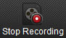 button to finish recording. A prompt box will pop up if all the operations succeed, as shown in Figure 1.
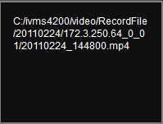
Figure 1 Local Recording Succeed

6.2 NVR Recording
Through iVMS-4200, user is able to configure the recording schedule for any added channels and store the recorded files in the NVR storage server.

Add NVR Server
- While installing iVMS-4200 software, please select PC NVR Server as well to enable NVR software, shown as figure below.
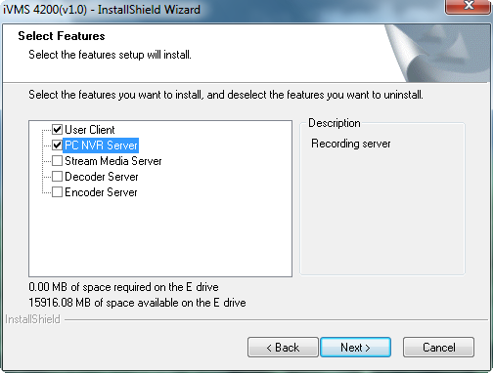
Figure 2 Install PC NVR Server

- Click 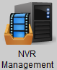 button in the Control Panel then click button to add NVR server.
- Fill the NVR server login information including Nick Name, IP address, Port number, User Name (admin by default) and Password(12345 by default) shown as in figure below. Then click “Add” button to finish.
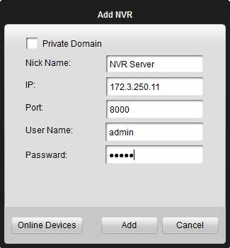
Figure 3 Add NVR
- After NVR server is added successfully, click button and go to HDD sub-menu and select a local HDD in the server for storing recorded files, then click button to format the HDD, shown as figure below:
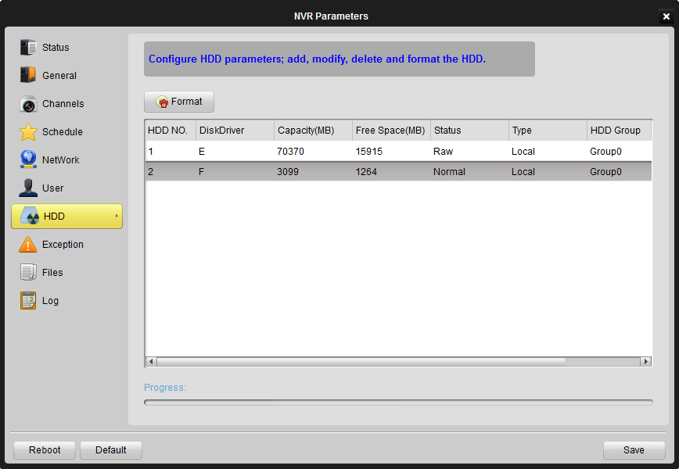
Figure 4 Format HDD

NVR Recording Schedule Setup
After having finished the adding of NVR server, user can define the recording template for the schedule recording settings.
- Add Recording Channels: Go to Channels sub menu of the NVR, and clickbutton and select a channel from the group, shown as figure below. You may also remove or get the channel information by clicking and buttons.
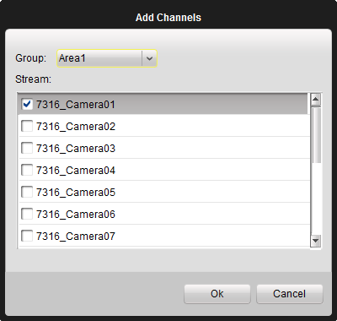
Figure 5 Add Channels

- Recording Schedule Setup: First please select a channel from the drop-down box to record on. Then click and select a recording schedule from the templates shown as below:
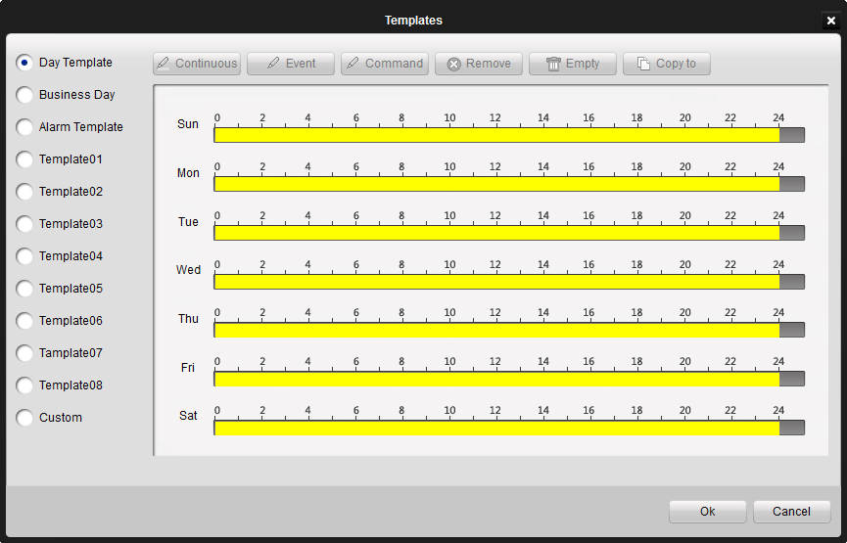
Figure 6 Recording Templates

This interface provides multiple choices of schedule template with 3 default template: Day Template for all-day continuous recording, Business Day for working-hours continuous recording from 8:00 AM to 8:00 PM; Alarm Template for all-day event recording) and 8 customized templates.
There are also three kinds of recording types:
- Yellow means continuous recording.
- Blue means event recording,
- Green means command recording.
Figure 7 Recording Types

The Custom template can be configured as below.
- Click Remove/Empty to delete existing schedule;
- Click Continuous/Event/Command to select Recording Mode;
- Drag the mouse on the schedule to specify a time bar (maximum: 8 bars), and the length of the time bar can be adjusted and the bar can be copied to other days. Click on the time bar to view the start and end time of this recording period.
- You may also define Template01-08 by clicking and repeating step a),b) and step c).

Notes:
- If you want to change recording resolution, bit rate or other recording parameters, please click Quality button in the Stream Configure panel and modify the main stream quality as needed.
- To ensure that event recording works properly, please setup motion detection area, schedule/alarm schedule first and then enable trigger camera recording. More details in Stream Configure Chapter.
- Command recording function is only available when iVMS-4200 added ATM DVR while the ATM transactions are taking place.

6.3 Remote Recording
When the video storage devices are HDDs or SD/SDHC cards installed in the DVR or IP cameras, users may adopt remote recording mode as well.
- Format the HDD or SD/SDHC card: After adding the devices into iVMS-4200, please go to configure menu of Device Management Panel and then HDD sub-menu to format the storage devices first, shown as figure below.
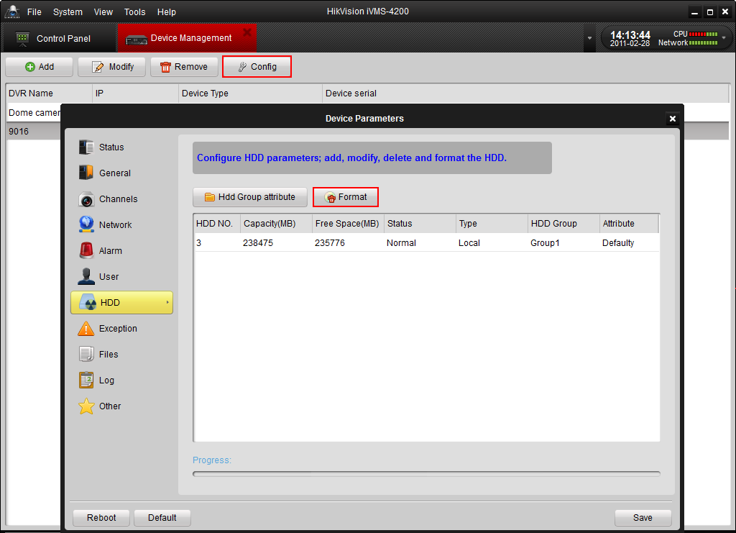
Figure 8 Format the HDD

- Enable Use DVR option: Go to Stream Configure Panel and tick the box in front of the Use DVR option of the Schedule tab.
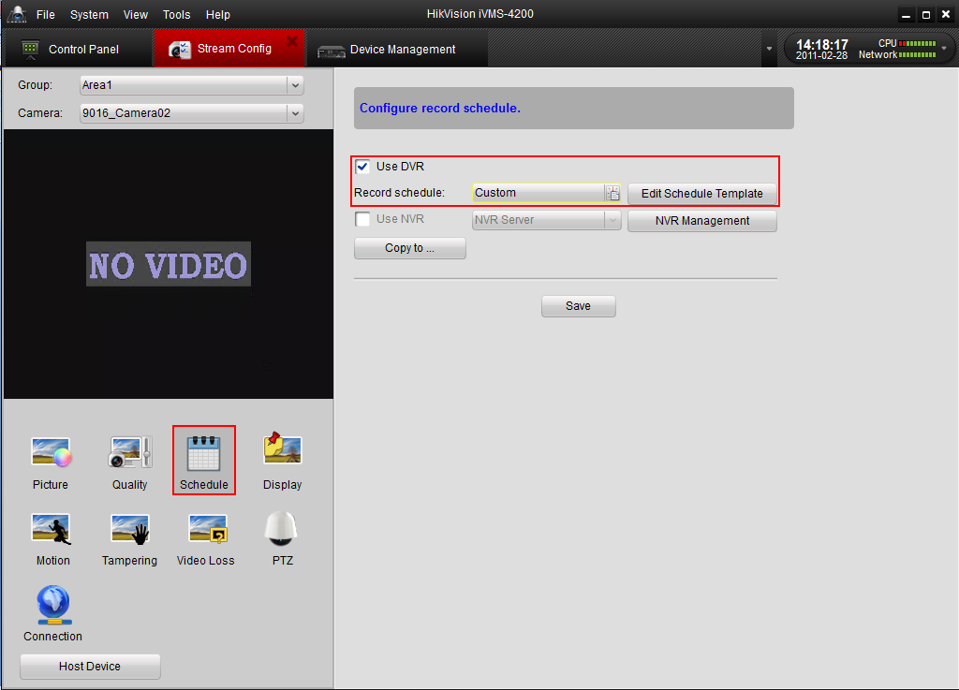
Figure 9 Enable Use DVR Option

- Recording Schedule Setup: After enabling the Use DVR option, please click and select a recording schedule from the templates shown as below:
Figure 10 Recording Templates

This interface provides multiple choices of schedule template with 3 default template: Day Template for all-day continuous recording, Business Day for working-hours continuous recording from 8:00 AM to 8:00 PM; Alarm Template for all-day event recording) and 8 customized templates.
There are also three kinds of recording types:
- Yellow means continuous recording.
- Blue means event recording,
- Green means command recording.
Figure 11 Recording Types

The Custom template can be configured as below.
- Click Remove/Empty to delete existing schedule;
- Click Continuous/Event/Command to select Recording Mode;
- Drag the mouse on the schedule to specify a time bar (maximum: 8 bars), and the length of the time bar can be adjusted and the bar can be copied to other days. Click on the time bar to view the start and end time of this recording period.
- You may also define Template01-08 by clicking and repeating step a),b) and step c).

Notes:
- If you want to change recording resolution, bit rate or other recording parameters, please click Quality button in the Stream Configure panel and modify the main stream quality as needed.
- To ensure that event recording works properly, please setup motion detection area, schedule/alarm schedule first and then enable trigger camera recording. More details in Stream Configure Chapter.
- Command recording function is only available when iVMS-4200 added ATM DVR while the ATM transactions are taking place.

7. Playback
Based on the different recording modes, the playback function consists of three playback modes: Local playback, Instant Playback and Event Playback.

7.1 Local Playback
Playback the video files created in local recording mode.
- Go to Main View panel and click Local Clips. And then select a camera; specify the start time and the stop time, click Search button and the eligible video clips will list below, shown as figure 12.
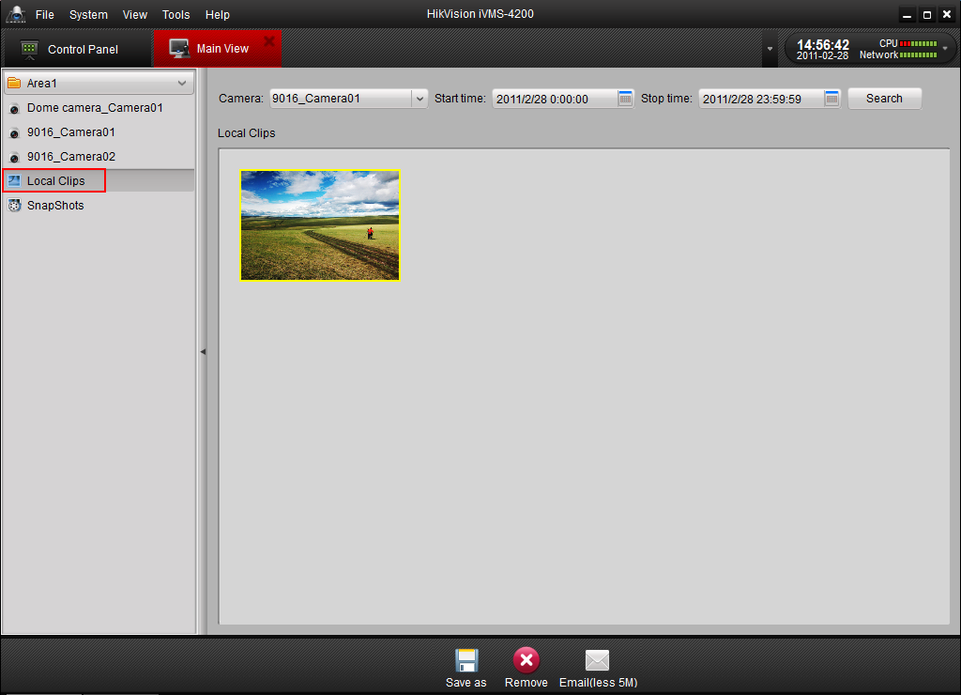
Figure 12 Local Playback

- Double click the video clips, and then a player will pop up. User can click button to view the video, click and buttons to fast or slow play the video. Please note that button is designed to play the video frame by frame, which means single clicking the button, the video will move one frame forward. If you want to play other video files in the local disk, please click button and select a video file.
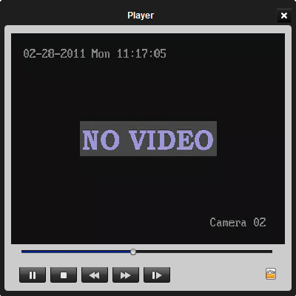
Figure 13 Player

7.2 Instant Playback
Playback the video files created in remote or NVR recording mode.
- Go to Main View panel, double-click a channel to enable the tool bar shown as below, and click button to start instant playback.
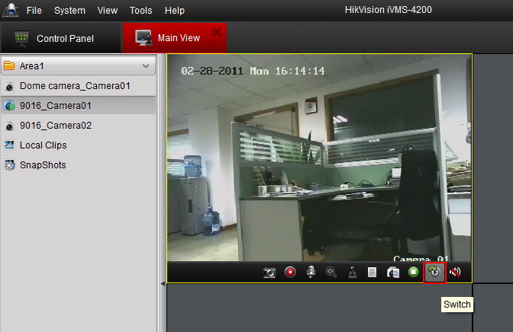
Figure 14 Start Instant Playback

- In instant playback interface, please click button to start playback the first video files of current day; click and buttons to fast or slow play the video. Please note that button is designed to play the video frame by frame, which means single clicking the button, the video will move one frame forward.

Button | Description
 | Picture capture
 | Start/Stop video cutting
 | Download the video file
 | Start/Stop instant playback
 | Audio button, click to open and close audio

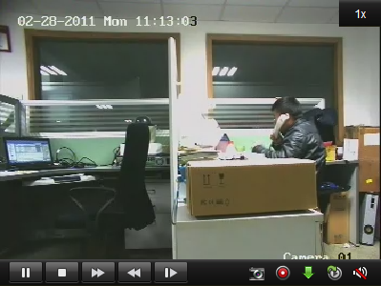
Figure 15 Instant Playback

- You may also use the time bar at the bottom of the Main View panel to adjust the playback progress. Also and buttons are used to expand and narrow down the time bar so user can choose a more accurate playback time.
Figure 16 Time Bar

7.3 Event Playback
Playback the video files of event type.
- Go to Event Search panel and select an event type: motion or input (i.e. alarm input).
- Choose a camera in the group and specify a start time, then click Search button.
- Select a window, and double-click a video file from the search results list to play.
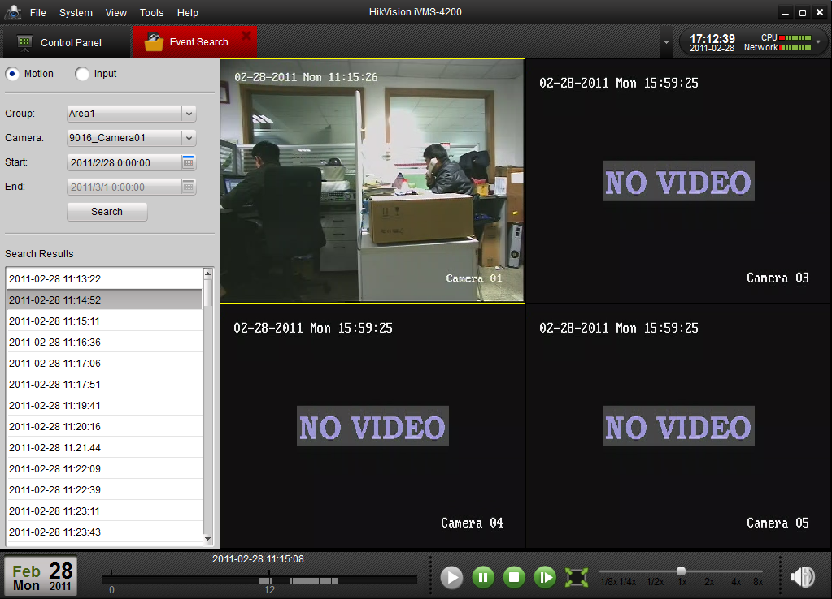
Figure 17 Event Search

- During play back the video, you may right click the mouse in the image to get a drop-down menu shown as figure 18, please refer to the table below for more details on this menu. You may also change playback speed by clicking on the 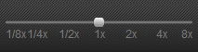 bar.

Button | Description
 | Picture capture
 | Start/Stop the video cutting
 | Download the video file
 | Audio button, click to open and close audio
 | Select a recording-triggered channel for playback
 | Full screen

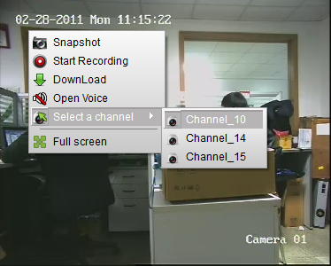
Figure 18 Event Playback

Notes:
- Event playback function is only available for NVR/DVR which support event recording.
- Make sure to import all the channels that you wish to play back in Stream Import panel.
- It is also required to enable continuous recording on all the alarm/motion-triggered channels before event playback.

8. Backup

8.1 Backup Snapshot
After configuring all settings, click 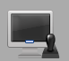 to enter the main view interface (Figure 8-1). To preview the live video, drag the camera from the left list to the right display window.

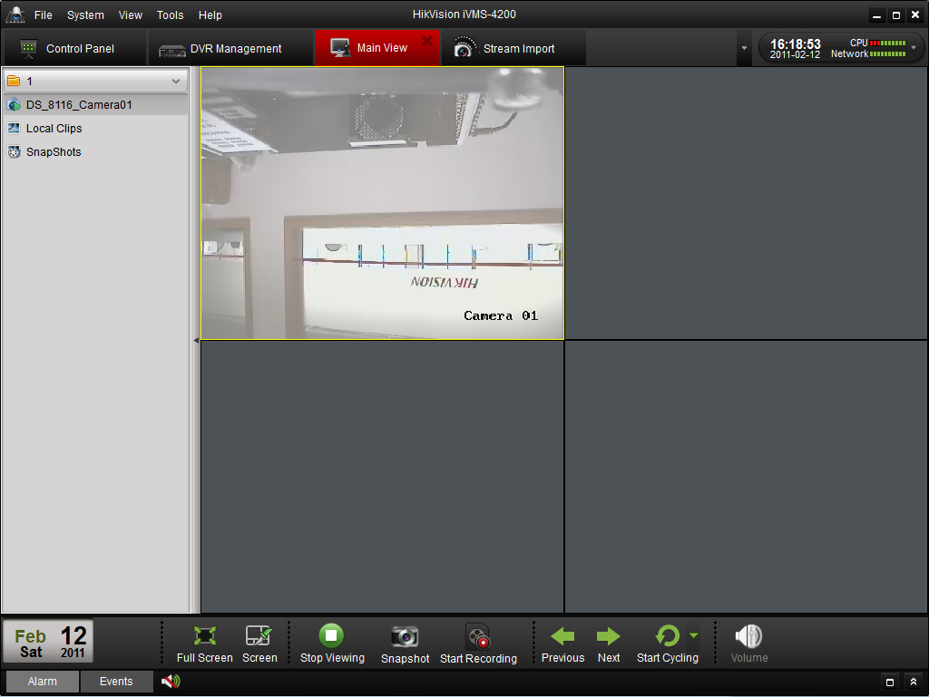
Figure 8-1 Main View
Click 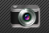to backup snapshot, and a snapshot window will popup as followed (Figure 8-2). Click to choose the location for the backup snapshot (Figure 8-3).
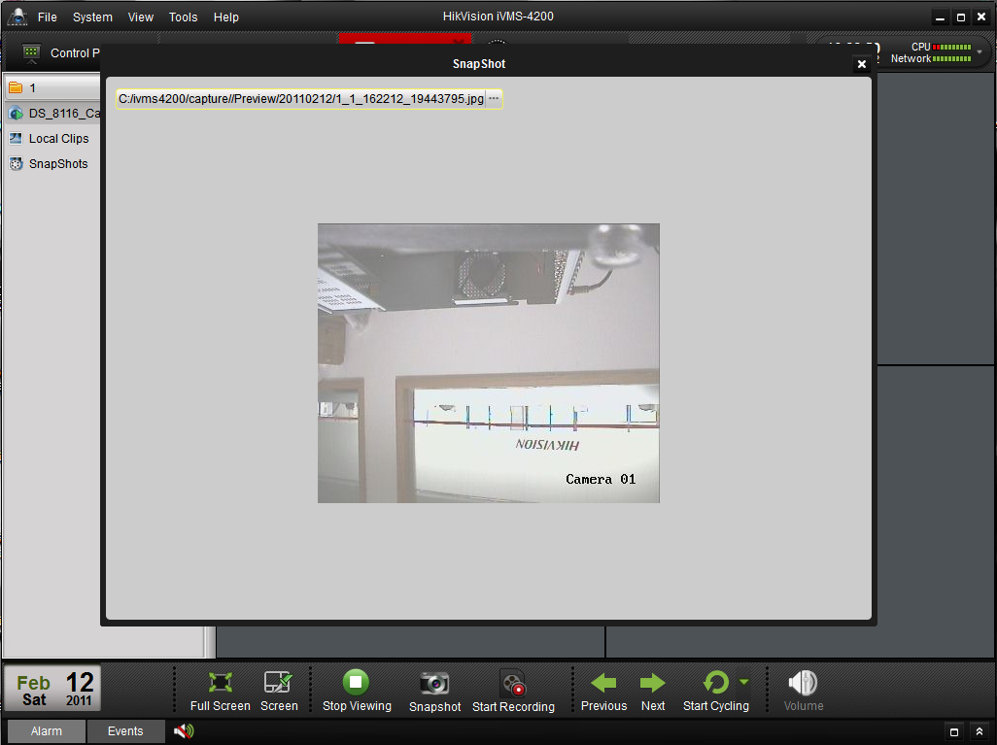
Figure 8-1 Snapshot in Live View
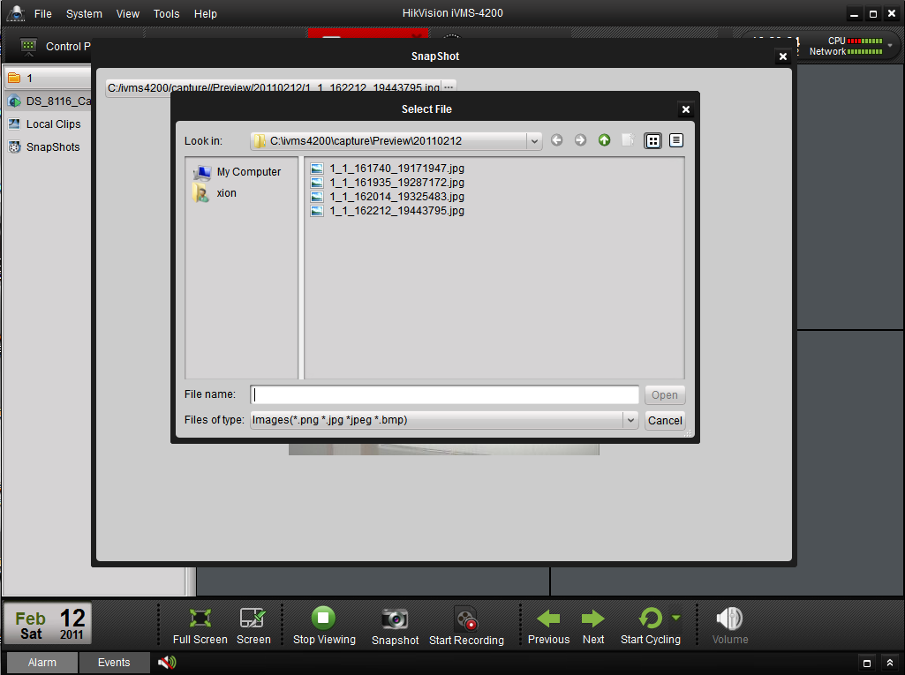
Figure 8-3 Change the Directory for Snapshot Image

8.2 Backup Video Clips

Click Local Clips in the left area in the main view interface. The local clips search interface as followed. It provides a fast video clips search way by choosing a different camera and setting a period of record (Figure 8-4 Backup Video Clips).

Click 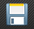 to backup video clips.
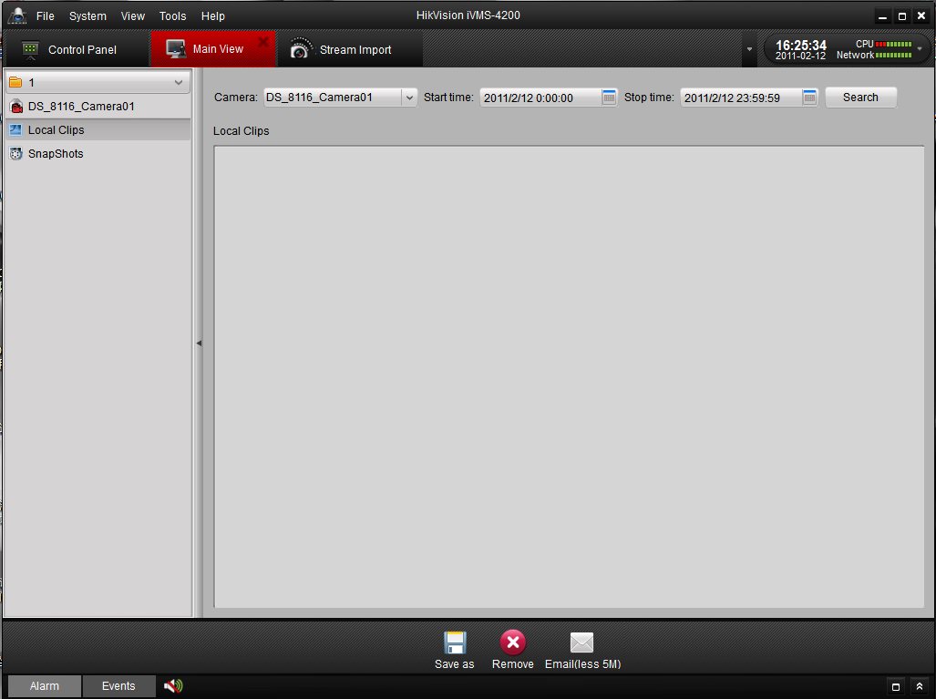
Figure 8-4 Backup Video Clips

9. Stream & Device Configuration

9.1 Stream Configuration
Click on the “Stream Config” icon 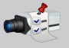 in the control panel to enter the stream configuration interface (Figure 9-1)
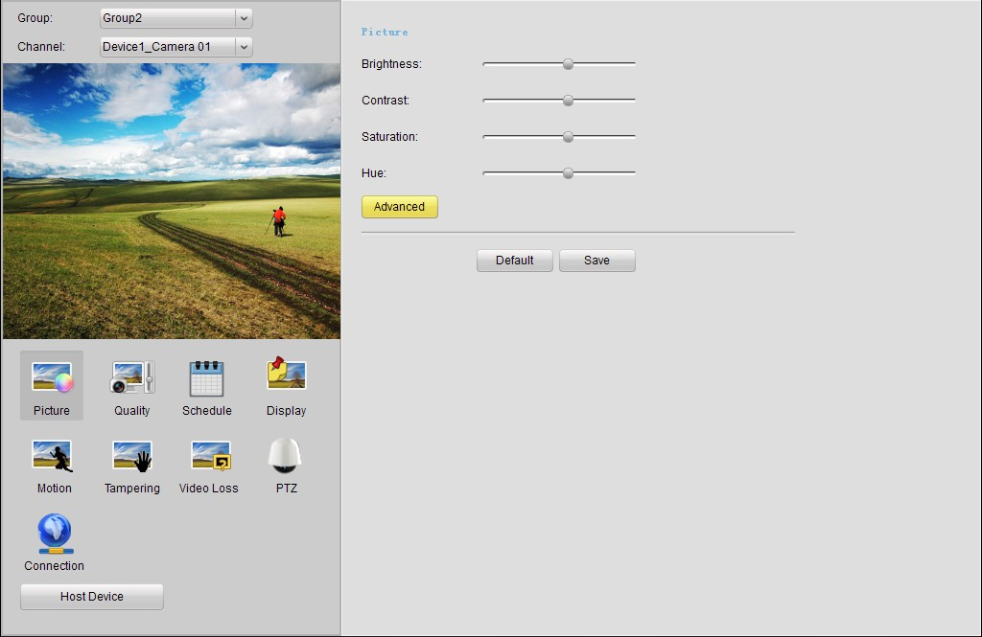
Figure 9-1 Stream Configuration
Select the Group name and Channel name for the stream on the upper left side of the interface, and the video image will be displayed in the region below. Click on different icons in the bottom left area to enter different configuration pages. Click on the icon and the relative device configuration dialog box will be displayed.

Button | Description
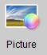 | Video picture parameters configuration
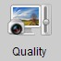 | Video encoding quality configuration
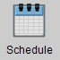 | Recording schedule configuration
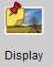 | Configure information to be displayed on the video
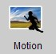 | Motion detect configuration
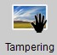 | View tampering alarm configuration
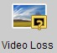 | Video loss alarm configuration
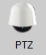 | PTZ Configuration
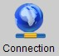 | Network parameter configuration for the stream

9.1.1 Picture
In the picture configuration interface, user can adjust the brightness, contrast, saturation and hue of the video image (Figure 9-2). Drag the round icon to adjust the level from lowest to highest.
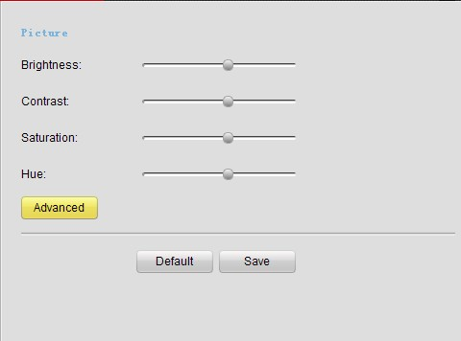
Figure 9-2 Picture Configuration
If the stream connected is from an IP camera which supports CCD parameter configuration, users can click the icon to enter CCD configuration interface. Please refer to the network camera user manual for detail description of this operation.
Click icon to restore default level of brightness, contrast, saturation and hue configuration.
After the entire picture configuration is done, click icon to save the configuration.

9.1.2 Quality

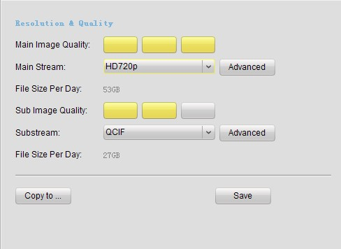
Figure 9-3 Quality Configuration
Users can set separate video resolution and video quality for main stream and sub stream. Select the encoding resolution in “Main stream” or “Sub stream”, and click on the position of the block-indicators to select the appropriate video quality setting for the camera stream. 3 yellow blocks indicates highest video quality with highest bit rate consumption (please refer to “File Size per Day” to get the data bit consumption under the current video quality settings), while 1 yellow blocks indicates lowest video quality & bit rate.
Advanced users can also click the icon for more specific video quality settings including Stream Type, Bit Rate Type, Maximum Bit Rate, Frame Rate, Frame Type and I frame interval (Figure 9-4).
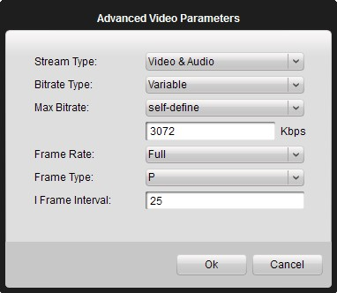
Figure 9-4 Advanced Video Parameters

9.1.3 Schedule
Users can set different recording schedules in this interface (Figure 9-5). “Use DVR” indicates that the recording schedule will be configured onto the device, and “Use NVR” indicates that the recording schedule will be configured onto a PC with NVR Server software. To assign an NVR Server for the recording schedule, please click to add 1 or multiple NVR server(s) (Figure 9-6), and then select the NVR server from the list.
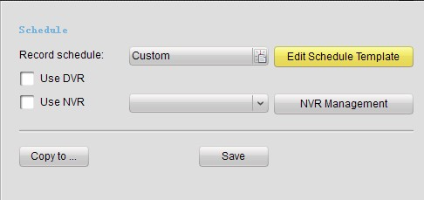
Figure 9-5 Schedule
Click to enter Schedule Template setting page (Figure 9-6). Click on [Continuous], [Event] or [Command] to select different recording mode, and then drag on each day’s time bar to configure the recording schedule. Click on a colored (configured) time interval to get this time period being selected and displays the scheduled time, and then click [Remove] to remove the selected time section from the recording schedule, or click [empty] to delete the entire record schedule for the current template. Click [Copy to] to copy the selected schedule section to other day (s), and after all the template settings are done, click to save the changes.
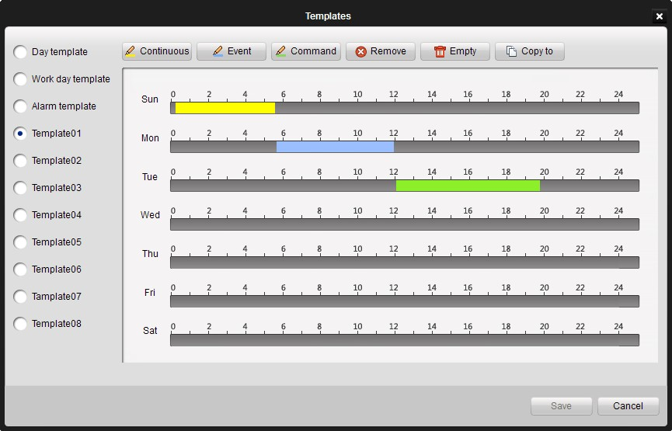
Figure 9-6 Edit Schedule Template
After schedule template has been configured and saved, user will go back to the schedule configuration page, and select the appropriate recording schedule from the list. Users can also click on the list and check the pop-up Schedule configuration page.

9.1.4 Display
[Display Camera Name]: Display the camera title on the video live view OSD
[Display Date]: Display the date on the video live view OSD
[Display Week]: Display the week on the video live view OSD
[Enable Tampering]: Enable privacy zone function on the video live view OSD
For the other text to be displayed on the video image, please input the content in “Text Display” and check it. If the content is unchecked, then it will not be displayed on the video image.
After all the display settings are done, click to save the changes.

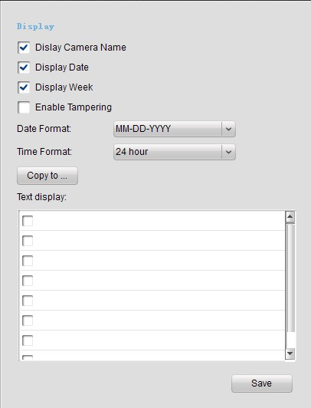
Figure 9-7 Display

9.1.5 Motion

To configure the motion detection function of the stream, please check [Enable Motion Detection] in the Motion configuration interface (Figure 9-8), and select a time schedule for the motion detection to take effect. The schedule template can be edited in the Schedule configuration interface.
[Actions] lists all the valid actions linked by motion detect. Check the actions that required to be done after motion detection is triggered.
[Audio Warning]: trigger audio warning on the device when motion detection is triggered.
[Upload to Center]: upload alarm information to the CMS software when motion detection is triggered.
[Trigger Alarm Output]: activate 1 or multiple channels of alarm output when motion detection is triggered. Users need to specify the corresponding alarm output channel (s) in the alarm output channel list.
[Email Linkage]: send an Email when motion detection is triggered. The email account settings are under “System Options” of the control panel. Please refer to Chapter 13 “System Options” for more detail.
[Warning on Monitor]: display warning on the local video output on the corresponding device of the selected stream.
[Trigger Recording]: trigger motion detection recording on the camera stream. Please select the stream(s) that required to be recorded on the motion detection of current stream in the stream input list.
After all the motion detection settings are done, click to save the changes.
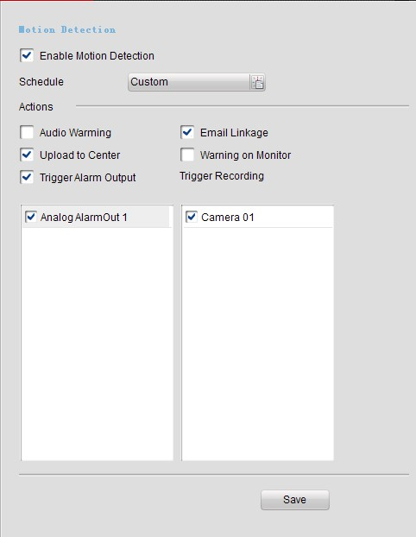
Figure 9-8 Motion

9.1.6 Tampering
To configure the view tampering detection function of the stream, please check [Enable Cover Detection] in the Tampering configuration interface (Figure 9-9), and select a time schedule for the tampering detection to take effect. The schedule template can be edited in the Schedule configuration interface.
[Actions] lists all the valid actions linked by view tampering. Check the actions that required to be done after tampering detection is triggered.
[Audio Warning]: trigger audio warning on the device when tampering detection is triggered.
[Upload to Center]: upload alarm information to the CMS software when tampering detection is triggered.
[Trigger Alarm Output]: activate 1 or multiple channels of alarm output when tampering detection is triggered. Users need to specify the corresponding alarm output channel (s) in the alarm output channel list.
[Email Linkage]: send an Email when tampering detection is triggered. The email account settings are under “System Options” of the control panel. Please refer to Chapter 13 “System Options” for more detail.
[Warning on Monitor]: display warning on the local video output on the corresponding device of the selected stream.
After all the tampering settings are done, click to save the changes.
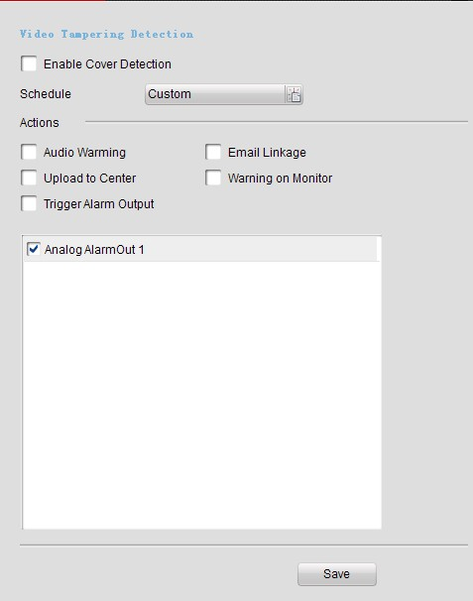
Figure 9-9 Tampering

9.1.7 Video Loss
To configure the video loss detection function of the stream, please check [Enable Video Loss Detection] in the Tampering configuration interface (Figure 9-10), and select a time schedule for the video loss detection to take effect. The schedule template can be edited in the Schedule configuration interface.
[Actions] lists all the valid actions linked by video loss detection. Check the actions that required to be done after video loss detection is triggered.
[Audio Warning]: trigger audio warning on the device when video loss detection is triggered.
[Upload to Center]: upload alarm information to the CMS software when video loss detection is triggered.
[Trigger Alarm Output]: activate 1 or multiple channels of alarm output when video loss detection is triggered. Users need to specify the corresponding alarm output channel (s) in the alarm output channel list.
[Email Linkage]: send an Email when video loss detection is triggered. The email account settings are under “System Options” of the control panel. Please refer to Chapter 13 “System Options” for more detail.
[Warning on Monitor]: display warning on the local video output on the corresponding device of the selected stream.
After all the video loss detection settings are done, click to save the changes.
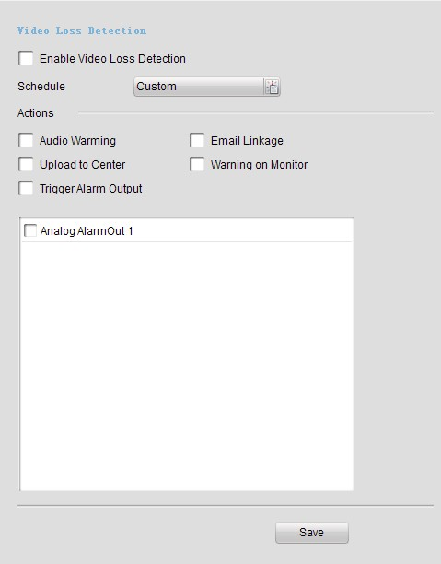
Figure 9-10 Video Loss

9.1.8 PTZ
In the PTZ configuration page, users can specific the PTZ connection parameters, such as baud rate, data bits, stop bits, parity, flow control, PTZ protocol and PTZ address (Figure 9-11). Please notice that all these PTZ parameters should be consistent with the local settings on the PTZ to ensure valid PTZ control.
Click to copy all the PTZ settings to another stream. After all the PTZ settings are done, click to save the changes.
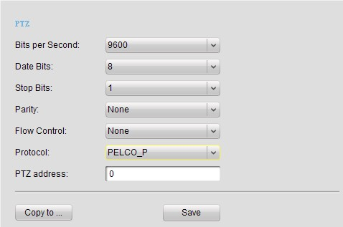
Figure 9-11 PTZ

9.1.9 Connection
In the Connection configuration page, users can specific the protocol and stream type of the camera, and configure stream media server (Figure 9-12).
If [Use Stream Media Server] is enabled, please click , click [Add] in the popup dialog box and input the stream media server information to assign a stream media server for the stream.
Click to copy all the Connection settings to another stream. After all the Connection settings are done, click to save the changes.
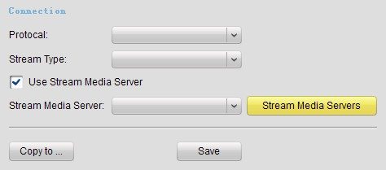
Figure 9-12 Connection

9.2 Device Configuration
Click on the “Device Management” icon 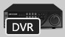 in the control panel, select the device, and click button to enter the device configuration interface (Figure 9-13). User can also enter device configuration interface via button in the stream configuration interface, or via the button in the “device management” under Stream Import interface.

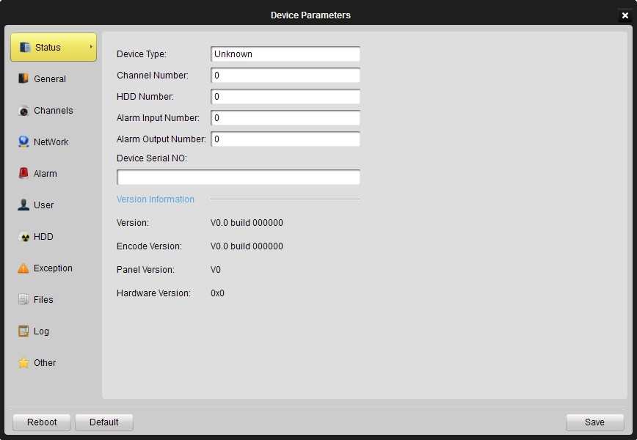
Figure 9-13 Device Configuration - Status

9.2.1 Status
In this status page (Figure 9-13), users can check the basic information of the device, including device type, total channel number, HDD number, physical Alarm I/O number, device SN, and also version information. For the version information, [Version] indicates firmware version, [Encode Version] indicates the encoder’s version, [Panel Version] indicates the front panel version of the device, and [Hardware Version] indicates the hardware version of the device.

9.2.2 General
In the general configuration page (Figure 9-14), users can configure some general properties of the device.
[Device Name]: user can define the name of the device, which will be displayed on the device list of the software.
[Device No.]: device number for the remote controller.
[Record Replace]: overwrite HDDs when HDDs are full.
[Main BNC Scale]: scale image display on the main BNC output.
[Spot BNC Scale]: scale image display on the spot BNC output.
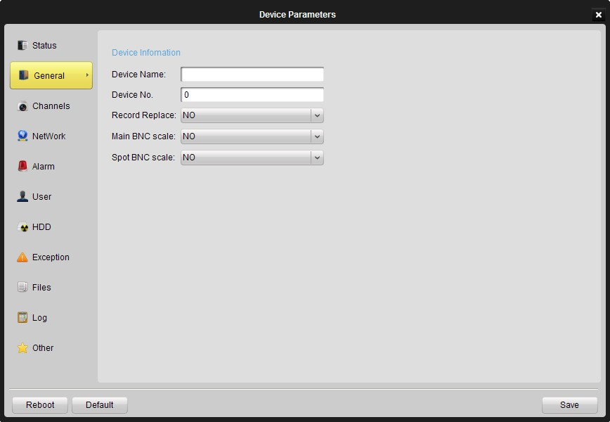
Figure 9-14 Device Configuration - General

9.2.3 Channels
In the channels configuration page (Figure 9-15), users can enable/disable analog channels of the device, and the disabled channels will not be added into the software stream import. And for the hybrid DVR or NVR which has digital channels, users can add, delete and modify an IP channel by clicking relative buttons on the configuration page, and fill in the IP channel information accordingly.
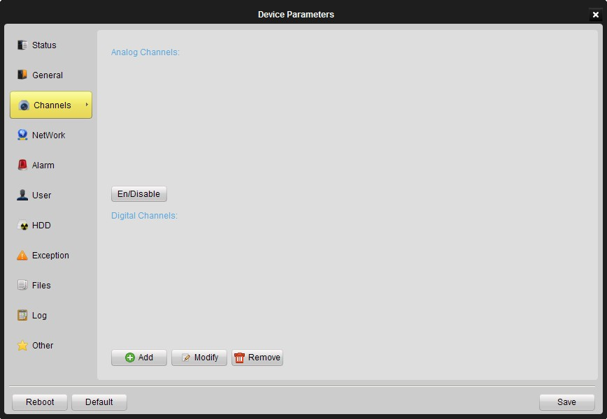
Figure 9-15 Device Configuration - Channels

9.2.4 Network
In the network configuration page (Figure 9-16), users can configure network parameters for the device.
[NIC Type]: NIC type of the device.
[Device IP Address]: IP address of the device.
[Device Port]: network port of the device, the default port number is 8000.
[Subnet Mask]: sub net mask IP for the device.
[Default Gateway]: default gateway IP for the device.
[Mac]: Mac address of the device, this is a read-only field.
[Multicast]: multicast address of the device, please leave this field empty if multicast is not required.
[http Port]: Web service port of the device, the default port number is 80.
[NTP]: NTP time synchronization. Click the [Settings] button to configure NTP server and the time zone.
[Email]: Email account settings for the device. Click the [Settings] button to configure SMTP server parameters.
[PPPoE]: Click the [Settings] button to configure PPPoE parameters.
[DDNS]: Click the [Settings] button to configure DDNS parameters.
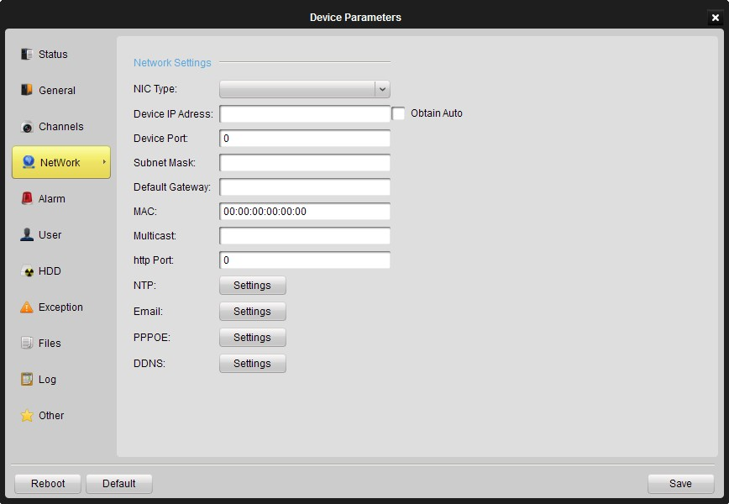
Figure 9-16 Device Configuration - Network

9.2.5 Alarm
In the alarm configuration page (Figure 9-17), users can configure Alarm I/O and linkage actions for the device.
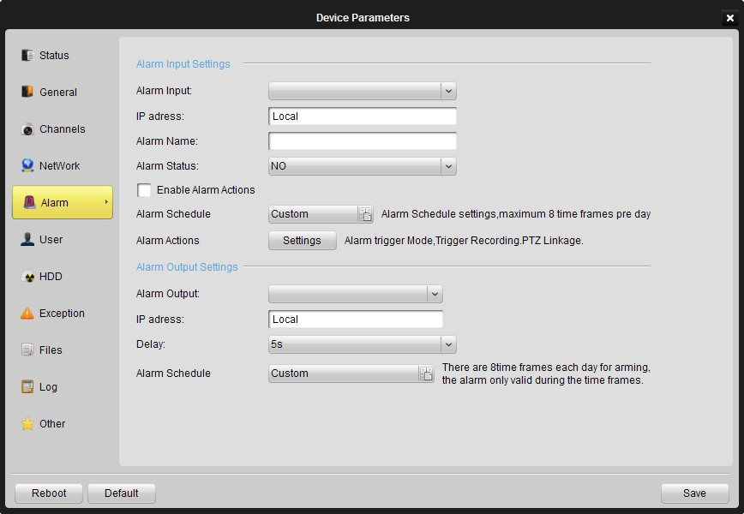
Figure 9-17 Device Configuration - Alarm
Alarm input settings:
[Alarm Input]: select an alarm input channel for configuration.
[IP Address]: IP address for the digital alarm input. ‘Local’ stands for the hard-wired alarm input interface on the device. This is a read-only field.
[Alarm Name]: define a name for the alarm input channel.
[Alarm Status]: NO stands for normal open and NC stands for normal close.
Users should check [Enable Alarm Action] to activate alarm action settings.
[Alarm Schedule]: set the time schedule to handle the alarm triggering, which is also called ‘Arm schedule’. The schedule template is configured in “Schedule” configuration page of stream configuration. Please refer to Section 9.1.3 for detail description of operation steps.
[Alarm Actions]: Click [Settings] to enter alarm action settings (Figure 9-18). Check the alarm action(s) which are required to be activated after the alarm input has been triggered, and select corresponding channel number if required.
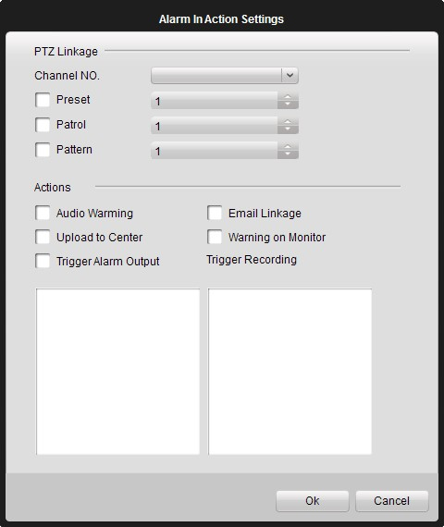
Figure 9-18 Alarm Actions

Alarm output settings:
[Alarm Output]: select an alarm output channel for configuration.
[IP Address]: IP address for the digital alarm output. ‘Local’ stands for the hard-wired alarm output interface on the device. This is a read-only field.
[Delay]: select the delayed time duration for the alarm output.
[Alarm Schedule]: set the time schedule to activate the alarm output, which is also called ‘Arm schedule’. The schedule template is configured in “Schedule” configuration page of stream configuration. Please refer to Section 9.1.3 for detail description of operation steps.

9.2.6 User
In the user configuration page (Figure 9-19), authorized users can create users accounts and assign different privileges for each account.
Click ‘Add’, ‘Modify’ or ‘Remove’ to create/edit/delete a user account. The created user account(s) with basic information will be listed in the area below.
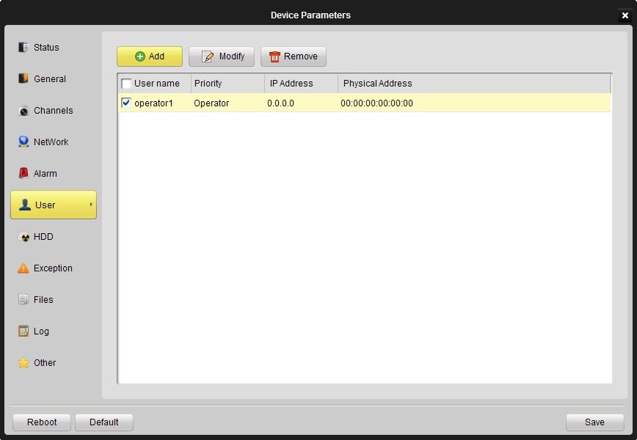
Figure 9-19 Device Configuration - User
When adding or editing a user account, users can set different user rights in the ‘User Parameters’ dialog box (Figure 9-20). Select privileges that required to be open for the created user account, and then click [OK] to confirm the configuration.
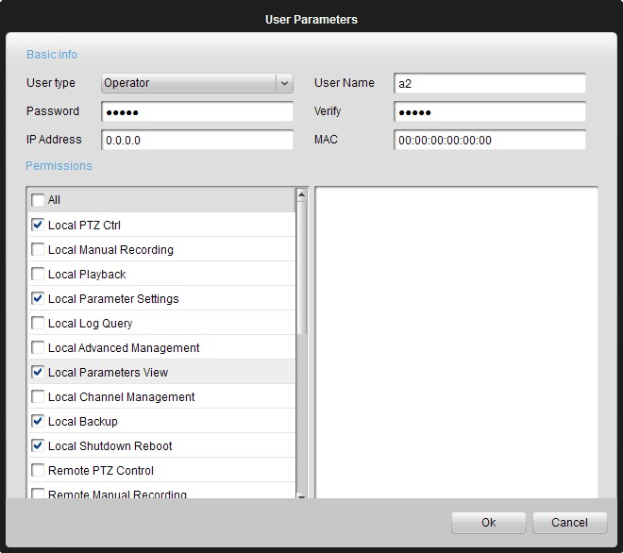
Figure 9-20 User Configuration

9.2.7 HDD
In the HDD configuration page (Figure 9-21), all the HDD installed on the device will be listed with basic information, and users can configure HDD groups via [HDD Group Attribute], or format the HDD via [Format] button on the HDD configuration interface.
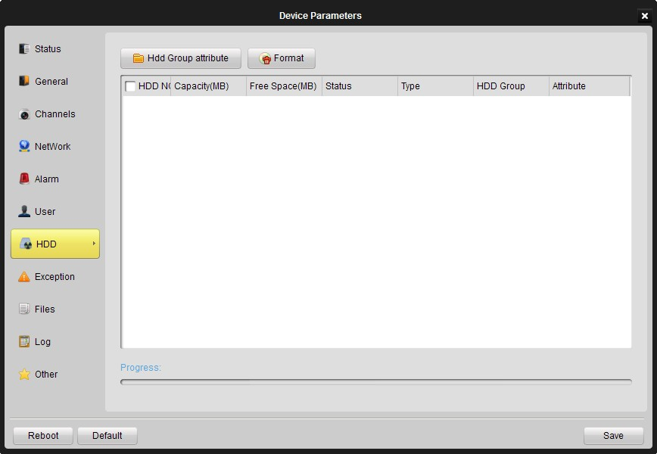
Figure 9-21 Device Configuration - HDD

9.2.8 Exception
In the exception configuration page (Figure 9-22), select the exception type, and check the linkage actions accordingly under ‘Alarm Handle Method’ (also select the channel number in ‘Alarm Output’ if ‘Trigger alarm output’ is enabled). Different linkage actions can be configured for different exception type.
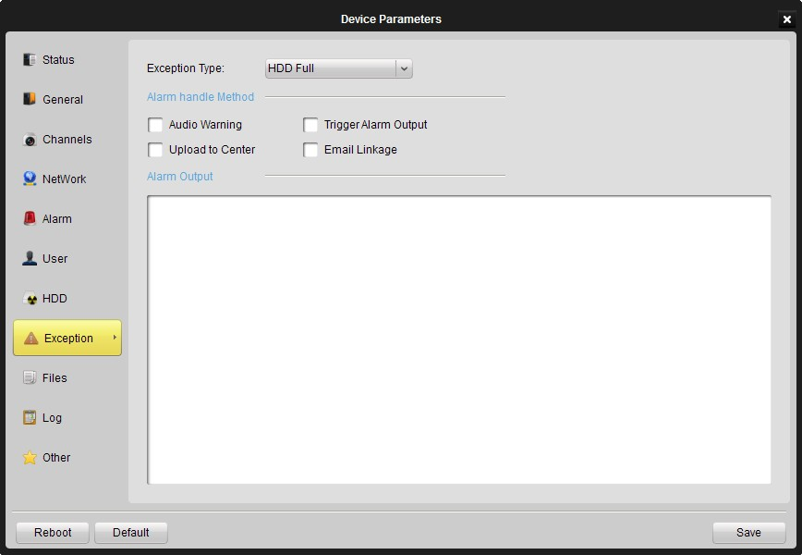
Figure 9-22 Device Configuration - Exception

9.2.9 Files
Recording files query on the local device (Figure 9-23). Select the [Channel Number], select different file attribute (i.e. All, motion, alarm, etc), define the start and end time of the log files, and then click [Search]. The record file will be listed accordingly. Select relative files and click [Backup] to backup all the selected files.
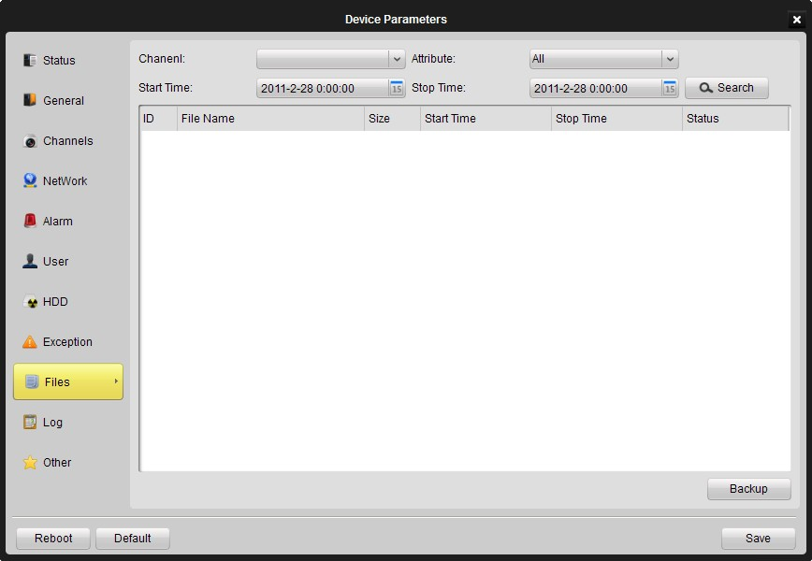
Figure 9-23 Device Configuration - Files

9.2.10 Log
Log file query on the local device (Figure 9-24). Select the [Query Mode], select different main type and sub type of the log file, define the start and end time of the log files, and then click [Search]. The log file will be listed accordingly.
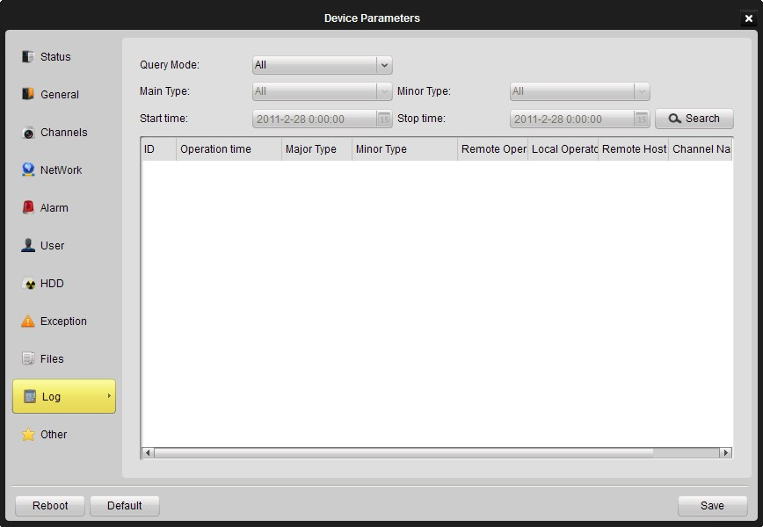
Figure 9-24 Device Configuration - Log

9.2.11 Other
Serial port configuration and remote upgrade settings on the local device (Figure 9-25). Please notice that the baud rate, data bits, stop bits, parity, flow control and work mode should be consistent with the protocol settings on the device which is connected to the serial port.
For the remote upgrading function, click […] to browse and select the upgrade file, and then click [Upgrade] to start upgrading. The upgrading process will be displayed and reboot is required when the upgrading process is finished.
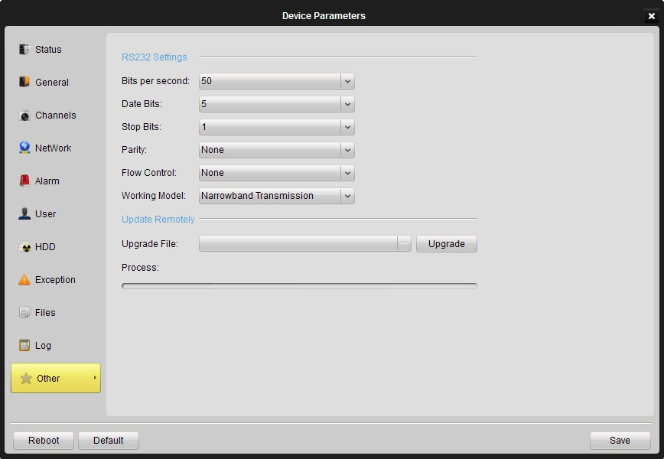
Figure 9-24 Device Configuration - Other

Chapter 10 E-Map
Click “View”->”E-Map View” or Click 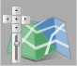 on the main interface to enter E-Map.
Following is main view of E-Map.
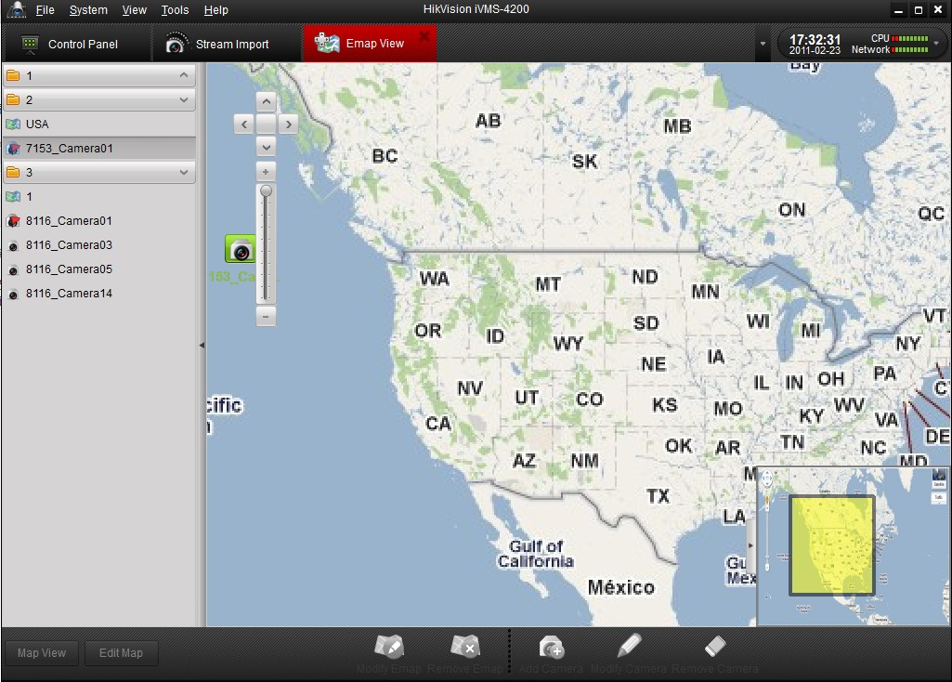

10.1 Add E-Map
For the first time to use E-Map, users are required to add a map first. Click 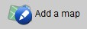 to add a new map.
Notice: One group can only add one map.
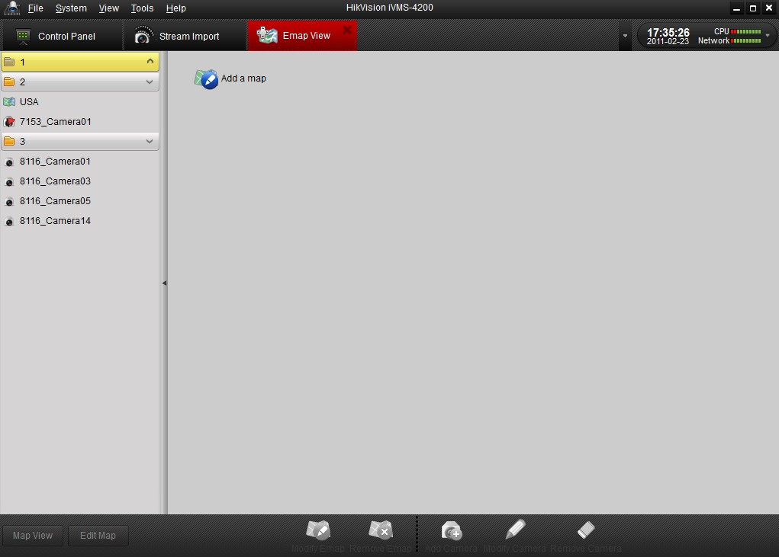
Enter in name of Map, and select it from your local PC.
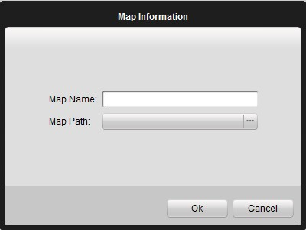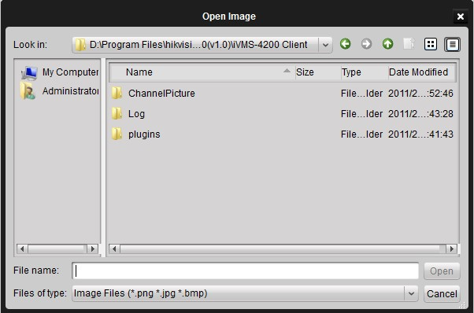
Notice: Map format should be *png, *jpg or *bmp.
After add map successfully, it will show on the window and name of map also appears on the list of group.

Toolbar buttons description:

Button | Description
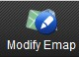 | Modify map, change map name or path.
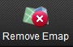 | Remove map.
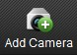 | Make camera show on the map
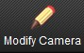 | Modify hotspot name and select which camera to show the map.
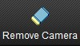 | Remove selected camera from map.
 | E-Map is under view state
 | E-Map is under edit state
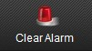 | Clear alarm display on E-Map manually.

10.2 Edit E-Map
If E-Map is in ‘edit’ status, click or double click the map name on the left side of the software interface to get map editing window. Users can modify map name and change another map here.
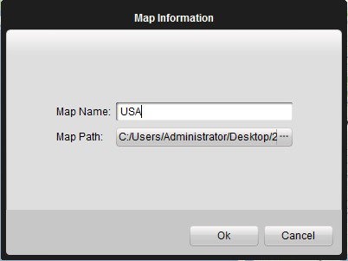

It is available to show the location of cameras on the map. There are two ways to do that, click and select which camera you want to add, then move it to the right position. Or you can just drag camera from the list to the right position.
If there is alarm triggered, icon  will appear near the camera icon to notify the users.

10.3 Delete E-Map
Click to delete map.

Chapter 11 Hardware decoding
iVMS 4200 client software allows the access of the 6000DI, 6300DI and 6401HDI Decoder for decoding and outputting the network video signal from DVR, DVS, IP Camera and IP speed dome and display of the video on TV wall as well.

11.1 Add hardware decoder
Before controlling the decoder, user needs to add the decoder.
Users are able to add a new decoder in both “Decoder Server” and “TVwall View” interface.
Click 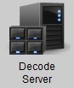to enter decoder server interface.
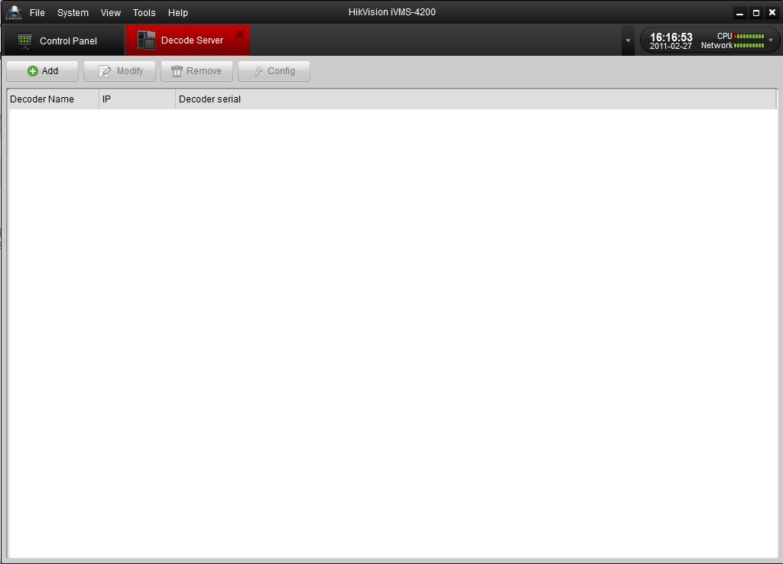
Or click 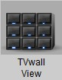to enter TVwall View interface.
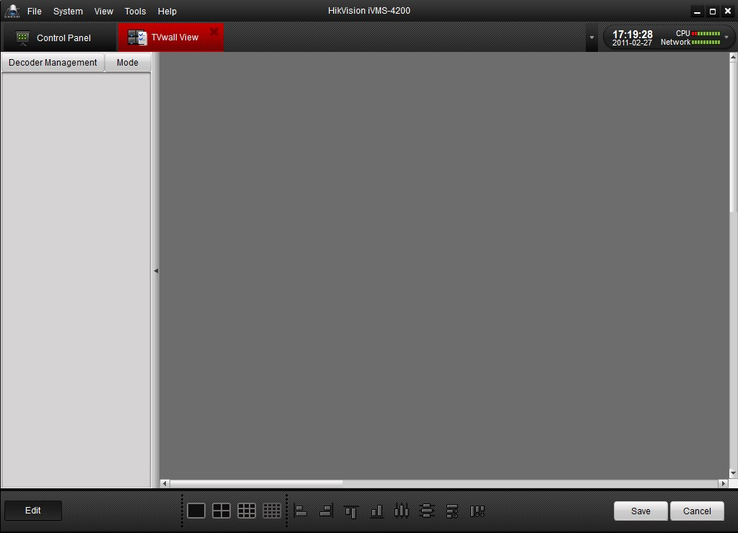
Click to enter devices management interface, more details refer to Chapter 9, device management.
Then Clickto add decoder. Following dialog box pop up.
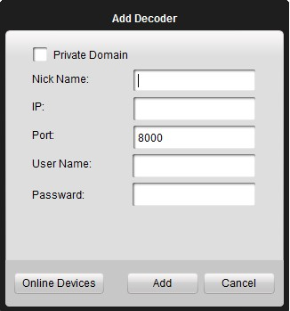
You can enter in IP address if you know or click to detect devices in the same LAN. More details refer to Chapter 9, device management.

11.2 Edit TV Wall
After the decoder has been added successfully, the device name will be displayed in the device list on the left.
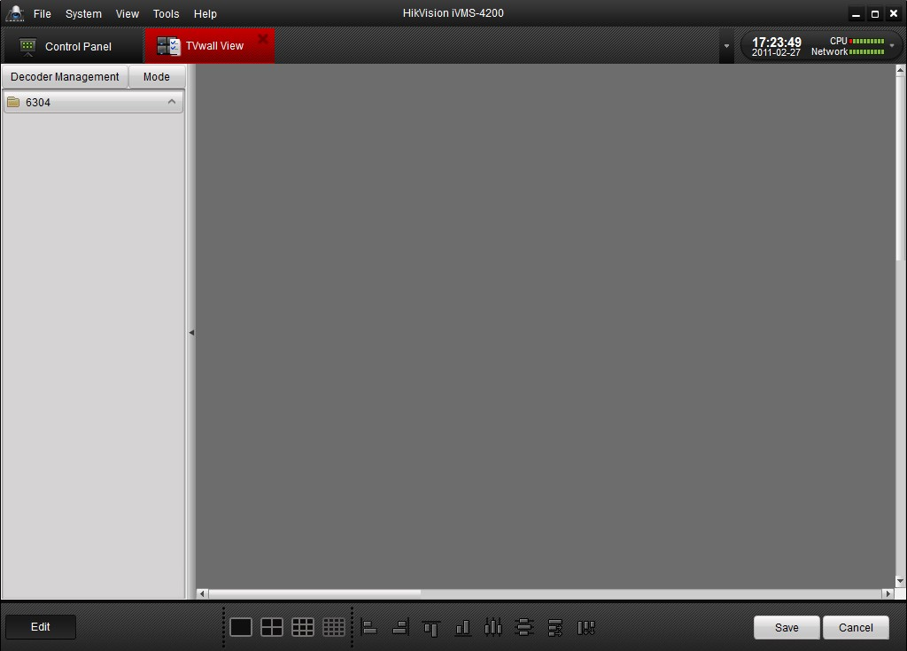
Click to select video wall mode.
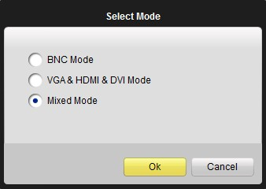

Notice: There are 3 modes: BNC mode, VGA & HDMI & DVI mode and Mixed mode, and users can choose which output they want to use.

Drag one or more output (VGA or BNC) from the output list (Area one) to the blank area (area 2).
After the decoder has been added successfully, the decoder channels will be displayed in the decoder list (Area 1). If the decoder supports VGA, it will display the VGA output. The 6300DI decoder supports simultaneous BNC and VGA outputs, and 6401HDI provides BNC, VGA, HDMI and DVI output.
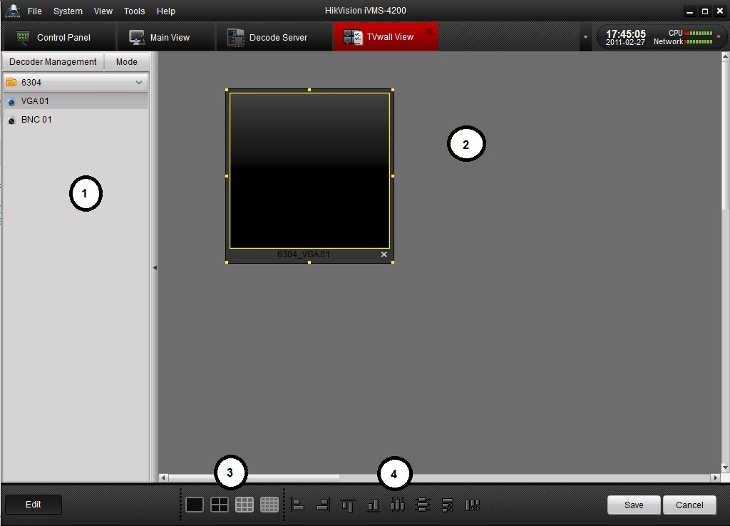
System Panel
Area | Description
① | List of decode output channels
② | Decode channel display
③,④ | Toolbar
Users can divide screen as 1/4/9/16 by 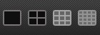.

Decoder layout toolbar:
Button | Description | Button | Description
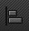 | Left align |  | Right align
 | Right align |  | Bottom align
 | Center vertically |  | Center horizontally
 | Equal horizontal distance |  | Equal vertical distance

Notice: The decoding resource of DS-6000DI, DS-6300DI, DS-6101DI and DS-6401HDI is shown as below:
Resolution/Decoder Model | Decoding Channel Number
Resolution/Decoder Model | DS-6000DI |  |  | DS-6300DI |  |  | DS-6101DI | DS-6400HDI
Resolution/Decoder Model | 6001DI | 6004DI | 6008DI | 6301DI | 6304DI | 6308DI | 6101DI | 6401HDI
CIF | 1 | 4 | 8 | 4 | 8 | 16 | 4 | 4
4CIF | 1 | 4 | 8 | 2 | 4 | 8 | 1 | 4
720P | N/A |  |  | 1 | 2 | 4 | N/A | 2
1080P | N/A |  |  | N/A |  |  | N/A | 1

11.3 Add streams into TV wall
Click to save settings or to leave current edit mode interface without anything change.
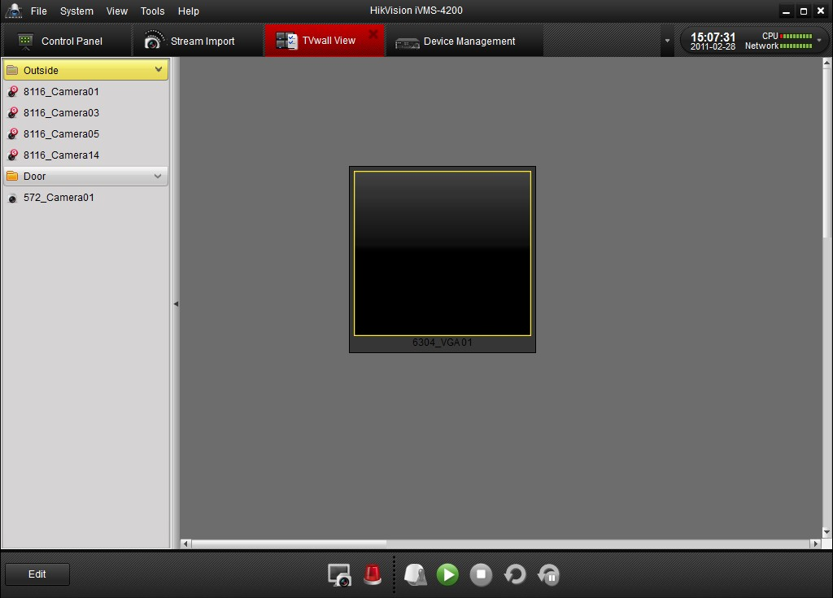
There are three modes to add streams into TV wall, Preview, Alarm and Cycle decoding.
Click 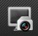 or 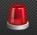 to switch between Preview and Alarm mode.
If it is in Preview mode, drag channel from left list to window, then it start decoding and show on the video wall.
If it is in Alarm mode, Click in “Alarm Events” to start decoding channel which alarm occurred.
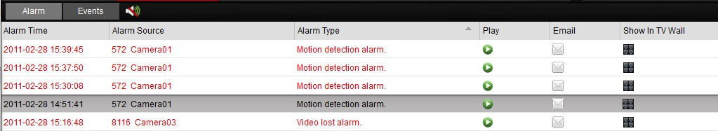
Drag the whole group into window and it start cycle decoding.
Pause / Recover cycle decoding
Right click window to pop up a dialog box and select Pause or Recover cycle decoding. Or just by clicking / on the bottom.
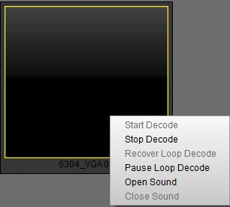
Buttons | Description
 | Preview mode
 | Alarm mode
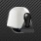 | PTZ mode
 | Play
 | Stop
 | Start cycle decoding
 | Stop cycle decoding

Chapter 12 Log

12.1 Log query
Users are able to search logs by type, group, time, user and camera. Select search criteria of log , and click .
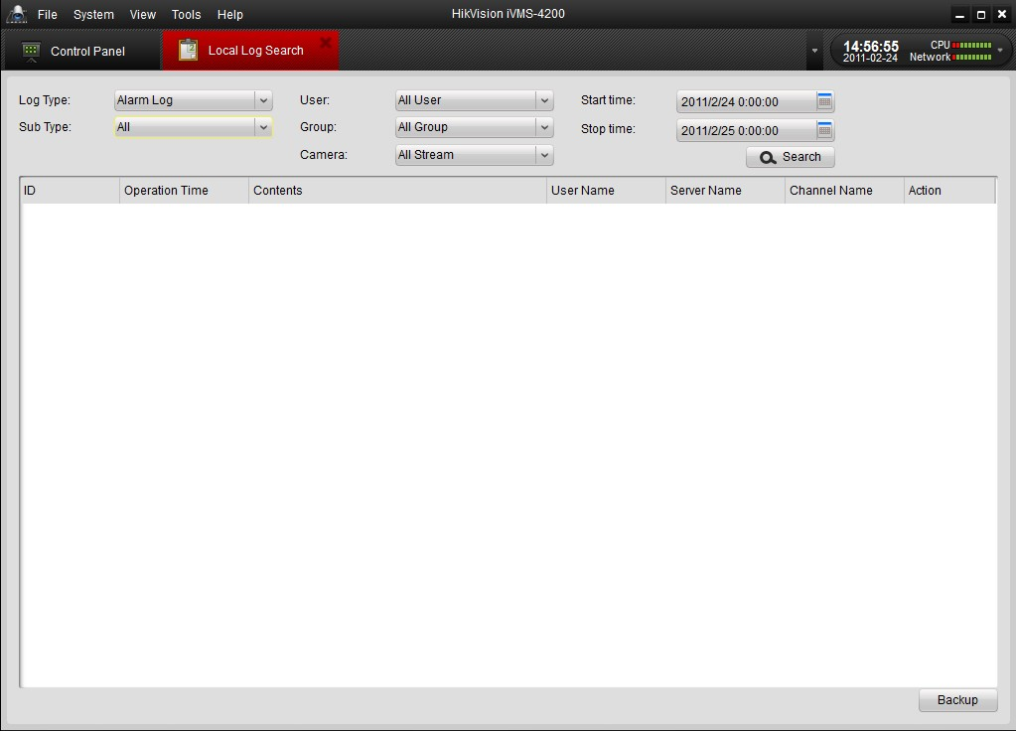

12.2 Export Log
Click and select device path to save log files. Log file export as .XML file.
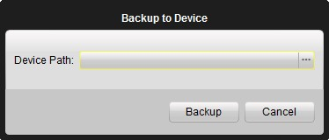

13. System Configuration
Click on the “System Options” icon 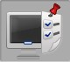 in the control panel to enter the stream configuration interface (Figure 13-1)

13.1 General
In the General system configuration page (Figure 13-1), users can set general configuration for the local PC.
[TV Wall Dwell Time (s)]: switching cycle for the TV wall display. Unit: second.
[On-line Status Indicator]: check this option to display on-line status for the input streams.
[Log Expired Time (days)]: previous log files older than the specific expire time will be deleted and not display on log query.
[Image Quality]: general image quality settings for the local software.
[Enable Tool Bar]: enable tool bar to display with the software.
[Auto Start]: software auto-start when system boots.
[Automatic Login]: automatically login the software without user account validation.
Users can click to save the current configuration, or click to reset all the system options to the default level.
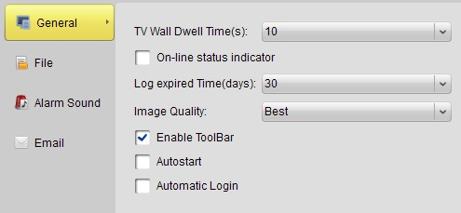
Figure 13-1 System Configuration - General

13.2 File
In the File configuration page (Figure 13-2), users can set the file directory to store video recording, snapshot and remote configuration file export. Click […] to open the file browser and select the file directory accordingly.
Users can click to save the current configuration, or click to reset all the system options to the default level.
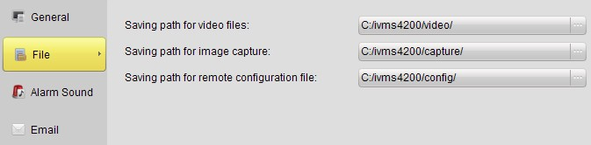
Figure 13-2 System Configuration - File

13.3 Alarm Sound
In the alarm sound configuration page (Figure 13-3), users can select different audio wave file for different types of alarm triggering. Click […] to open the file browser, and select an audio wave file for the selected alarm type.
Users can click to save the current configuration, or click to reset all the system options to the default level.
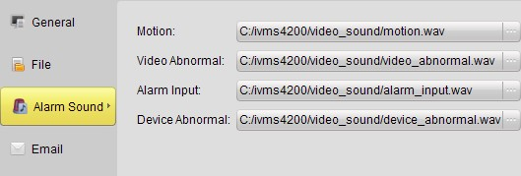
Figure 13-3 System Configuration - Alarm Sound

13.4 Email
In the email configuration page (Figure 13-4), users can set the SMTP account information for the alarm action of the local software. Input correct SMTP information according to the mail server, and click to check if the test message can be send to the email address successfully.
Users can click to save the current configuration, or click to reset all the system options to the default level.
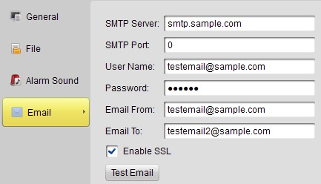
Figure 13-4 System Configuration - Alarm Sound

14. FAQ

14.1 Live View
Question:
How to get the live view image from a HIKVISION device?
Answer:
Step 1. Add the device into the software device list; please refer to section 4.1 for more details.
Step 2. Add a channel from the device from the device list into a group. Please refer to section 4.3 for group operation.
Step 3. Open the Main View interface from the Control Panel, and drag the stream from the group list on the left side to the display window.

14.2 Recording
Question: How to set motion detection recording from a HIKVISION device?
Answer:
Step 1. Configure event recording mode in recording schedule setup. For motion detection recording on NVR, please refer to Section 6.2.3; and for motion detection recording on the device, please refer to Section 9.1.3.
Step 2. Configure Motion Detection parameters, including motion detection area, sensitivity and linkage options (please enable ‘upload to center’ option for motion recording on NVR) in the stream configuration. Please refer to Section 9.1.5 for setup details of motion detection.

14.3 Playback
Question: How to search for video files recorded under certain event mode?
Answer:
Step 1. Go to Event Search panel and select an event type: motion or input (i.e. alarm input).
Step 2. Choose a camera in the group and specify a start time, then click Search button.
Step 3. Select a window, and double-click a video file from the search results list to play.

14.4 Configuration
Question: How to set encoding parameters in the device configuration?
Answer:
The encoding parameters should be set separately for each stream, and it is configured in ‘Stream Configuration’ setup page. Click on the “Stream Config” icon in the control panel to enter the stream configuration interface.

