Day/ Night Micro Color Camera
USER’S MANUAL
Version 2.0.0

Thank you for purchasing our product. If there is any question or request, please do not hesitate to contact dealer.
This manual is applicable to DS-2CC502/512/592P/N-DG1, DS-2CC502/512/592P/N-DG2 day/night micro color cameras.
This manual may contain several technically incorrect places or printing errors, and the content is subject to change without notice. The updates will be added into the new version of this manual. We will readily improve or update the products or procedures described in the manual.
 Safety Instructions
These instructions are intended to ensure that user can use the product correctly to avoid danger or property loss.
The precaution measure is divided into “Warnings” and “Cautions”
Warnings: Serious injury or death may cause if any of the warnings is neglected.
Cautions: Injury or equipment damage may cause if any of the cautions is neglected.
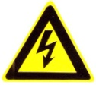 | 
Warnings Follow these safeguards to prevent serious injury or death. | Cautions Follow these precautions to prevent potential injury or material damage.
Warnings
1. In the use of the product, you must be strict compliance with the electrical safety regulations of the nation and region.
2. Input voltage should meet both the SELV(Safety Extra Low Voltage) and the Limited Power Source with AC 24V or DC 12V according to the IEC60950－1 standard. Please refer to technical specifications for detail information.
3. Do not connect several devices to one power adapter as adapter overload may cause over-heat or fire hazard.
4. Please make sure that the plug is firmly connected on the power socket.
5. When the product is mounted on wall or ceiling, the device shall be firmly fixed.
6. If smoke, odor or noise rise from the device, turn off the power at once and unplug the power cable, and then please contact the service center.
7. If the product does not work properly, please contact your dealer or the nearest service center. Never attempt to disassemble the camera yourself. (We shall not assume any responsibility for problems caused by unauthorized repair or maintenance.)
Cautions：
- Make sure the power supply voltage is correct before using the camera.
- Do not drop the camera or subject it to physical shock.
- Do not touch CCD (Charge Coupled Device) modules with fingers. If cleaning is necessary, use clean cloth with a bit of ethanol and wipe it gently. If the camera will not be used for an extended period, please turn on the lens cap to protect the CCD from dirt.
- Do not aim the camera at the sun or extra bright places. A blooming or smear may occur otherwise (which is not a malfunction however), and affecting the endurance of CCD at the same time.
- The CCD may be burned out by a laser beam, so when any laser equipment is on using, make sure that the surface of CCD will not be exposed to the laser beam.
- Do not place the camera in extremely hot, cold(the operating temperature shall be－10℃～＋60℃ ), dusty or damp locations, and do not expose it to high electromagnetism radiation.
- To avoid heat accumulation, good ventilation is required for operating environment.
- Keep the camera away from liquid while on using.
- While on a delivery, the camera shall be packed in its original packing, or packing of the same texture.
- Regular part replacement: a few parts (e.g. electrolytic capacitor) of the equipment shall be replaced regularly according to their average enduring time. The average time varies because of differences between operating environment and using history, so regular checking is recommended for all the users. Please contact with your dealer for more details.
Table of Contents
C H A P T E R 1 1
Introduction 1
1.1 Features 2
1.2 Functions 2
1.3 Structure 3
C H A P T E R 2 4
Specifications 4
Pinhole Camera 5
Dimensions 5
Wide-angel Camera for ATM 7
Dimensions 7

C H A P T E R 1

Introduction

1.1 Features
Adopting high performance CCD and advanced print circuit board design technology, the camera features high resolution, low distortion, low noise, etc., and thus is extremely applicable to the surveillance system and image processing system. It provides the following features:
• High performance image sensor CCD, high resolution, capable of providing clear images.
• Low illumination, color/B&W auto switch.
• Backlight compensation
• Auto white balance
• High DNR provides clear and pleased image.
• Auto electronic shutter control, adaptive to different environments.
• Auto gain control, with brightness adaptive.
• Advanced technique design, with high reliability.

1.2 Functions
ICR Switch: The camera provides two operation modes: color, and B&W. You can increase sensitivity in low light conditions by switching to B&W mode (removing the IR cut filter). Color mode is preferred in normal lighting conditions.
AGC: AGC allows users to adjust the gain of amplifier, enabling the camera to output the standard video signal in different lighting conditions. As scene lighting decreases, the system will automatically adjust, adding a mixture of AGC and slow shutter according to the AGC limit setting. In low illumination, AGC will increase camera’s sensitivity, and output bright and clear video.

S/N ratio: It refers to the ratio between signal voltage and noise voltage. While the ratio is larger, the effect of noise is less, and the image is more spotless.
White Balance: This feature automatically processes the viewed image to retain color balance over a color temperature range.
BLC: If a bright backlight is present, the subjects in the picture may appear dark or as a silhouette. Backlight compensation enhances objects in the center of the picture. The camera will adjust the iris so that the object in the sensitive area is properly exposed.
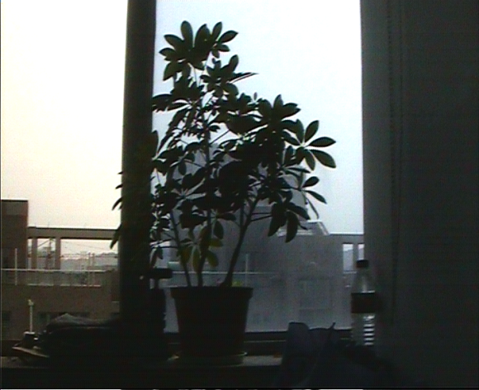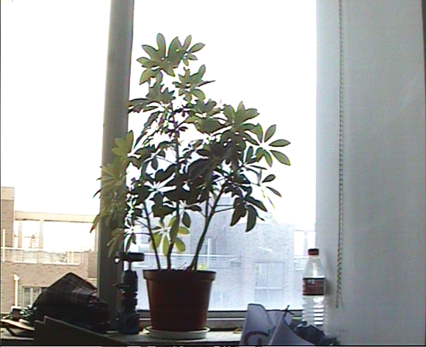
BLC OFF BLC ON

1.3 Structure
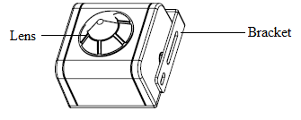
Front View
Lens: loosen or fasten screws to adjust the lens.
Bracket: used for mounting the camera.
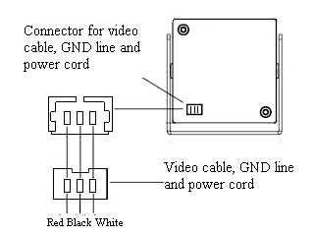
Rear Panel
Connector for video cable, GND line and power cord: provide three lines: video cable (white), GND line (black) and power cord (red) from left to right.

C H A P T E R 2

Specifications

Pinhole Camera
Parameter Model | DS-2CC502P/502N-DG1 | DS-2CC512P /512N-DG1 | DS-2CC592P / 592N-DG1
Image Sensor | 1/3"SONY Super HAD CCD
Signal System | PAL / NTSC
Effective Pixels | PAL:500 (H) × 582 (V)  NTSC:510 (H) × 492 (V) | PAL:752 (H) × 582 (V)  NTSC:768 (H) × 494 (V)
Min. Illumination | 0.05Lux @ F1.2 | 0.01Lux @ F1.2
Electronic Shutter | 1/50(1/60) ~ 1/100,000s
Lens | 3.7mm pinhole Lens
Horizontal Resolution | 420TVL | 480TVL | 540TVL
Synchronization | Internal Syn.
Video Output | 1Vp-p Composite Output (75Ω/BNC)
S/N Ratio | More than 50dB
BLC | ON
Working Temperature | -10℃ ~ 60℃
Power Supply | DC12V±10%
Power Consumption | 1.1W MAX | 1.5W MAX | 0.9W MAX
Dimensions (mm) | 30 × 32.5 × 19 | 38.5 × 40 × 19 | 25×25×17.5
Weight | 100g | 130g | 80g

Dimensions
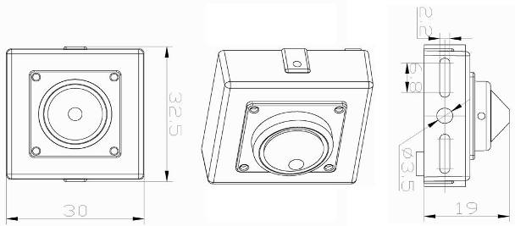
DS-2CC502P / N-DG1
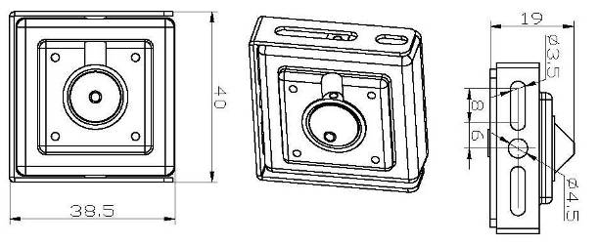
DS-2CC512P / N-DG1
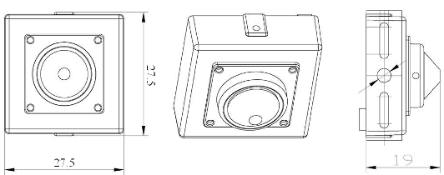
DS-2CC592P / N-DG1

Wide-angel Camera for ATM
Parameter Model | DS-2CC502P/502N-DG2 | DS-2CC512P /512N-DG2 | DS-2CC592P / 592N-DG2
Image Sensor | 1/3"SONY Super HAD CCD
Signal System | PAL / NTSC
Effective Pixels | PAL:500 (H) × 582 (V)  NTSC:510 (H) × 492 (V) | PAL:752 (H) × 582 (V)  NTSC:768 (H) × 494 (V)
Min. Illumination | 0.05Lux @ F1.2 | 0.01Lux @ F1.2
Electronic Shutter | 1/50(1/60) ~ 1/100,000s
Lens | 2.45mm wide angle lens
Horizontal Resolution | 420TVL | 480TVL | 540TVL
Synchronization | Internal Synchronization
Video Output | 1Vp-p Composite Output (75Ω/BNC)
S/N Ratio | More than 50dB
BLC | ON
Working Temperature | -10℃ ~ 60℃
Power Supply | DC12V±10%
Power Consumption | 1.1W MAX | 1.5W MAX | 0.9W MAX
Dimensions (mm) | 30 × 34.5 × 29 | 38.5 × 40 × 29 | 25.7 × 29 × 29
Weight | 100g | 130g | 90g

Dimensions
DS-2CC502P/N-DG2
DS-2CC512P/N-DG2
DS-2CC592P/N-DG2

