Day/ Night High-definition WDR Micro Color Camera
USER’S MANUAL
Version 2.0.0

Thank you for purchasing our product. If there is any question or request, please do not hesitate to contact dealer.
This manual is applicable to DS-2CC597P-DG1/DG2 Day/Night High-definition WDR Color Micro cameras.
This manual may contain several technically incorrect places or printing errors, and the content is subject to change without notice. The updates will be added into the new version of this manual. We will readily improve or update the products or procedures described in the manual.
Safety Instruction
These instructions are intended to ensure that user can use the product correctly to avoid danger or property loss.
The precaution measure is divided into “Warnings” and “Cautions”
Warnings: Serious injury or death may cause if any of the warnings is neglected.
Cautions: Injury or equipment damage may cause if any of the cautions is neglected.
 | 
Warnings Follow these safeguards to prevent serious injury or death. | Cautions Follow these precautions to prevent potential injury or material damage.
Warnings
1. In the use of the product, you must be strict compliance with the electrical safety regulations of the nation and region.
2. Input voltage should meet both the SELV(Safety Extra Low Voltage) and the Limited Power Source with DC 12V according to the IEC60950－1 standard. Please refer to technical specifications for detail information.
3. Do not connect several devices to one power adapter as adapter overload may cause over-heat or fire hazard.
4. Please make sure that the plug is firmly connected on the power socket.
5. When the product is mounted on wall or ceiling, the device shall be firmly fixed.
6. If smoke, odor or noise rise from the device, turn off the power at once and unplug the power cable, and then please contact the service center.
7. If the product does not work properly, please contact your dealer or the nearest service center. Never attempt to disassemble the camera yourself. (We shall not assume any responsibility for problems caused by unauthorized repair or maintenance.)
Cautions：
- Make sure the power supply voltage is correct before using the camera.
- Do not drop the camera or subject it to physical shock.
- Do not touch CCD (Charge Coupled Device) modules with fingers. If cleaning is necessary, use clean cloth with a bit of ethanol and wipe it gently. If the camera will not be used for an extended period, please turn on the lens cap to protect the CCD from dirt.
- Do not aim the camera at the sun or extra bright places. A blooming or smear may occur otherwise (which is not a malfunction however), and affecting the endurance of CCD at the same time.
- The CCD may be burned out by a laser beam, so when any laser equipment is on using, make sure that the surface of CCD will not be exposed to the laser beam.
- Do not place the camera in extremely hot, cold(the operating temperature shall be－20℃～＋60℃ ), dusty or damp locations, and do not expose it to high electromagnetism radiation.
- To avoid heat accumulation, good ventilation is required for operating environment.
- Keep the camera away from liquid while on using.
- While on a delivery, the camera shall be packed in its original packing, or packing of the same texture.
- Regular part replacement: a few parts (e.g. electrolytic capacitor) of the equipment shall be replaced regularly according to their average enduring time. The average time varies because of differences between operating environment and using history, so regular checking is recommended for all the users. Please contact with your dealer for more details.

Table of Contents
C H A P T E R 1 1
Introduction 1
1.1 Features 2
1.2 Functions 2
1.3 Structure 3
Menu Description 5
2.1 Menu Interface 7
2.2 Menu Programming 7
2.2.1 Camera ID Settings 7
2.2.2 Lens Type Settings 8
2.2.3 AWB Settings 8
2.2.4 BLC Settings 9
2.2.5 Wide Dynamic Settings 10
2.2.6 D/N Settings 11
2.2.7 AGC Settings 11
2.2.8 Language 12
2.2.9 Special Function 12
2.2.10 Exit 15
Appendix Specification 16
Day/ Night High-definition WDR Color Micro Camera 16

C H A P T E R 1

Introduction

1.1 Features
Adopting high performance CCD and CMOS advanced print circuit board design technology, the camera features high resolution, low distortion, low noise, etc., and thus is extremely applicable to the surveillance system and image processing system. It provides the following features:
• High performance SONY CCD, high resolution, 540TVL, capable of providing high-definition and clear images.
• Low illumination, Color: 0.1Lux @ F1.2, color/B&W auto switch for Day/Night surveillance.
• Wide dynamic range up to 160X applicable to surveillance in backlight environmental.
• OSD menu for programming setting parameters.
• Custom backlight compensation, with the compensation zones programmable.
• Auto white balance capability with high color rendition.
• High SNR provides clear and pleased image.
• Auto electronic shutter control, adaptive to different environments.
• Auto gain control, with brightness adaptive.
• Privacy mask capability with 8 optional colors and 8 programmable areas.

1.2 Functions
Motion Detection: The camera is capable of detecting the moving objects and trigger alarm. User can select different sensitivity level according to the corresponding environment.
Privacy Mask: Privacy Mask allows a user to program user-defined areas that cannot be viewed by the operator of the dome system. A masked area will move with pan and tilt functions and automatically adjust in size as the lens zooms telephoto and wide. A maximum of 8 privacy masks can be programmed.
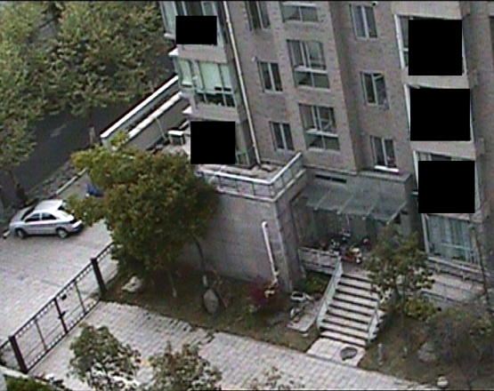
Color/B&W auto switch: The camera will automatically switch CCD light level according to various lighting conditions in the color/B&W mode. For example, the camera can be properly exposed to colorful image for enough light by daylight, while at night it will automatically adjust to low light level and display images clearly.
AGC: AGC allows users to adjust the gain of amplifier, enabling the camera to output the standard video signal in different lighting conditions. As scene lighting decreases, the system will automatically adjust, adding a mixture of AGC and slow shutter according to the AGC limit setting. In low illumination, AGC will increase camera’s sensitivity, and output bright and clear video.
S/N ratio: It refers to the ratio between signal voltage and noise voltage. While the ratio is larger, the effect of noise is less, and the image is more spotless.
OSD (On Screen Display) Menu: The camera features on-screen menu program. Multiple camera information display and parameters configuration are available with on-screen menu program.
White Balance: This feature automatically processes the viewed image to retain color balance over a color temperature range.
BLC: If a bright backlight is present, the subjects in the picture may appear dark or as a silhouette. Backlight compensation enhances objects in the center of the picture. The camera will adjust the iris so that the object in the sensitive area is properly exposed.
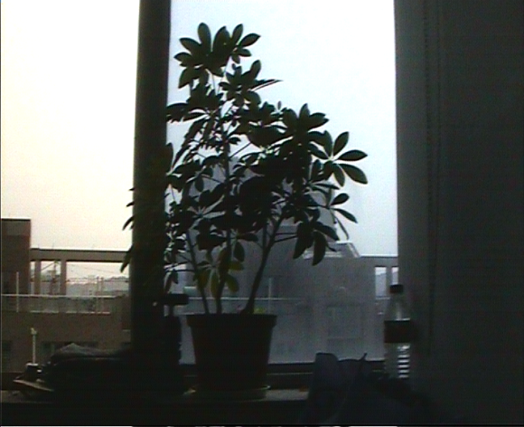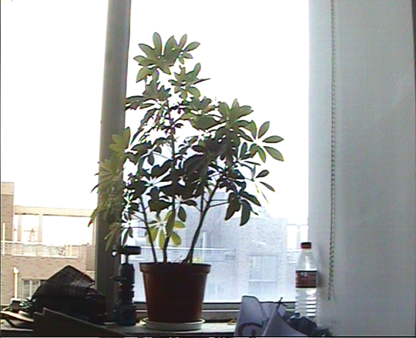
BLC OFF BLC ON
WDR: Wide dynamic range is used to balance the brightest and darkest section of a picture to provide more details on screen display.

1.3 Structure
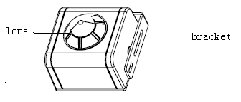
Front View

Lens: loosen or fasten screws to adjust the lens.
Bracket: used for mounting the mini camera.

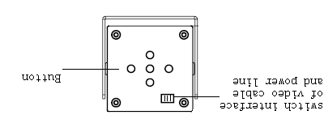

Connector for video cable and power cord

Menu Button

Rear Panel
Connector for video cable and power cord: provide three lines: video cable (white), GND line(black) and power cord (red) from left to right.
Menu button: The up/down/left/right buttons are corresponding to the up/down/left/right function respectively. Use up/down button to move the cursor, or left/right to change options. The middle button is the confirm button used to enter the selected menu.
C H A P T E R 2

Menu Description

2.1 Main Menu
Press the confirm button for about 2s, and then the OSD menu will appear on the screen:
Press up/down button to move cursor up/down, or left/right button to select different option.

2.2 Menu Programming

2.2.1 Camera ID Settings
Press up/down to move the cursor to CAM ID in the main menu, and then press left/right to select ON/OFF to enable or disable this setting.
OFF: disable the display of camera ID on the screen;
ON: disable the display of camera ID on the screen.
Select ON, and press the confirm button to enter Camera ID submenu.
Press up/down to move the cursor to the desired characters, numbers or symbols and then press the confirm button to edit the camera ID. If required, move the cursor to <CURSOR>, and press left/right to move it to the character in the camera ID that needs to be modified, and then press the confirm button to modify the character to be space. Move the cursor to Loc…and press the confirm button to enter the camera ID location setting interface, and then use up/down & left/ right to move the camera ID to the desired location. Press the confirm button to exit the camera ID location setting interface and return to the camera ID menu.
Move the cursor to RETURN and press confirm button to back to the previous menu.

2.2.2 Lens Type Settings
Press up/down to move the cursor to Lens in the main menu, and then press left/right to select the lens type to EIRIS or AIRIS (default type is EIRIS (electronic iris).
The electronic iris (EIRIS) adopts auto electronic shutter to adjust the brightness.
Select EIRIS and press the confirm button, and then the EI Setup menu will appear on the screen of the monitor.
Press up/down to move the cursor to the VALUE, and press left/right to adjust brightness (16 levels selectable). Move the cursor to RETURN and press confirm button to back to the previous menu.

2.2.3 AWB Settings
Press the up/down to move the cursor to WB in the main menu, and then press left/right to select the available options: ATW1, ATW2, ATC and MWB.
ATW1: Camera is capable of realizing perfect color recovery by utilizing TTL AWB algorithm, with the color temperature ranging from 2500K to 6500K.
ATW2: Camera is capable of realizing perfect color recovery by utilizing TTL AWB algorithm, with the color temperature ranging from 2500K to 15000K.
ATC: Adjust under steady color temperature environment. After selecting ATC in the menu and press the confirm button, the white balance will take effect to the current scene with the color temperature adjusted to 6500K;
MWB: Manually adjust red and blue values to set white balance.
Select MWB in the menu and press the confirm button to enter the MWB Setup submenu:
Press up/down to TEMP, and press the left button to select SUB to subtract the value of color temperature, or the right button to select ADD to add the value. After settings, move the cursor to RETURN and press the confirm button to back to the previous menu.

2.2.4 BLC Settings
Press up/down move the cursor to BLC/WD in the main menu, and press left/right to select OFF, BLC or WD. Select BLC and press the conform button to enter the BLC Setup submenu:

Move cursor to BLA AREA, and press left/right to set the BLC area to be UP, DOWM, LEFT, RIGHT, MID or SET, and then the BLC area will be displayed on the screen.
Set the user-defined BLC area according to the following steps:
Move cursor to SET, and press the confirm button to enter the submenu:
Move cursor to AREA, and press the confirm button to select OFF, LOC or AREA;
Press the confirm button to select LOC, and press up/down &left/right to set the BLA location;
Press the confirm button to select AREA, and press up/down &left/right to set the BLA size;
After settings, press the confirm button to select OK and move the cursor to RETURN, and finally press the confirm button to back to the previous menu.
Note: When the AREA has not been selected to OK, then it can not move the cursor by using up/down/left/right buttons. .
Press up/down to move the cursor to the VALUE, and press left/right to adjust BLC value (16 levels selectable). Move the cursor to RETURN and press confirm button to back to the previous menu.

2.2.5 Wide Dynamic Settings
Press up/down move the cursor to BLC/WD in the main menu, and press left/right to select OFF, BLC or WD. Select WD and press the conform button to enter the WD Setup submenu.
Press left/right to select the WD mode to be ON or AUTO.
AUTO: When the video image is present in low light conditions (e.g., at night) and the auto gain is required, the system has the capability to automatically turn off the wide dynamic function.
ON: In this mode the WD is in ON status all the time, which enables the video images to be clearer than that from the traditional camera, and the objects both in bright or dark conditions can be clearly viewed from the same monitor.
VALUE:
Press left/right to adjust value from 1 to 8 in VALUE1.
Press left/right to adjust value from 1 to 8 in VALUE2.
Wide Dynamic Contrast:
Press the confirm button to select the wide dynamic contrast to be High or Low.

2.2.6 D/N Settings
Press up/down to move the cursor to D/N in the main menu, and press left/right to select item from D/N, Color and Auto.
Auto Setting:
Select Auto in the menu and press the confirm button to enter the Auto D/N submenu:
Press up/down to move the cursor to VALUE, and press left/ right to select value from 0 to 7.
After settings, move the cursor to RETURN and press the confirm button to back to the previous menu.
Note: The Auto option indicates the D/N auto switch function of the camera, and values from 0 to 7 are corresponding to the switching threshold value in environmental lighting conditions from bright to dark.

2.2.7 AGC Settings
When the D/N mode is selected to be Color or B&W, the AGC function is enabled, with OFF, LOW, MID and HIGH levels selectable; while the D/N mode is selected to be Auto, the AGC function is disabled.

2.2.8 Language
Press up/down to move the cursor to CN/EN in the main menu, and press left / right to select CN (Chinese) or EN (English).

2.2.9 Special Function
Press up/down to move the cursor to SPECIAL in the main menu, and then press the confirm button to enter the Spec Func submenu.
DETEC
Press up/down to move the cursor to DETEC (Motion Detection), and press left/right to select OFF or OPEN.
Settings:
Move the cursor to select OPEN, and then press the confirm button to enter the Alarm submenu:
Press up/down to select Type1, and move cursor to AREA to select motion area from 1 to 4; move cursor to SENSOR and press left/right to select the sensitivity value from level 0 to 7. After settings, move the cursor to RETURN and press the confirm button to back to the previous menu.
Note: Type 1: 4 motion windows are available with size adjustable;
Type 2: Full screen;
Type 3: 12 × 8 default motion windows are displayed on full screen; each window can be cancelled by pressing the confirm button.
FLCMOD
Press up/down to move the cursor to FLCMOD (flicker proof function), and then press the confirm button to select the mode to be ON or OFF.
BLEMISH
After being used for a long time, the CCD (Charge Coupled Device) will encounter blemish problem. With blemish detection function, this series camera is capable of solving this problem. Move cursor to BLEMISH and press the confirm button, and then the character DETECT will turn to WAIT, which indicates the camera has enabled the blemish detection function. When the character WAIT turns to DETECT, the camera has finished the auto recovery operation.
Note: This function woks more effective in the absolutely dark environment. Make sure the variable iris of lens has been turned off before enabling this function.
VIDEO
Press up/down to move the cursor to VIDEO, and then press the confirm button to enter the Video Setup submenu.

GAMMA
Move cursor to GAMMA, and press left/right to set GAMMA value to 0.45 or 1.
DENOISE
Move cursor to DENOISE (Digital Noise Reduction) , and press left/right to set DENOISE to ON or OFF.
POS/ NEG
Move cursor to POS/NEG, and press left/right to select POS (positive) or NEG (negative). The video image appears normal when selecting POS while negative when selecting NEG.
RESOLUTION
Move cursor to RESOLUTION, and press left/right to select HIGH, MID, LOW or CLOSE to adjust the resolution of video image.
SHARP
Move cursor to SHARP, and press left / right to set the sharp value from 0 to 7.
Y
Brightness is adjustable from 0 to 7.
C
Saturation is adjustable from 0 to 7.

MASK
Move cursor to MASK, and press the confirm button to enter the Mask Setup submenu:
Move cursor to MASK NO to select the number (0-7) of privacy masks to be defined. A total of 8 privacy mask areas can be defined. Move cursor to ON/OFF, and press left/right to select ON. Move cursor to MASK SET and press the confirm button to edit mask area and size according to the following steps:
- Select LOC and press up/down/left/right to move the gray (optional color) quadrate area to the desired location, and then press the confirm button.
- Select AREA and press up/down/left/right to adjust the size of mask area.
- Repeat the same operation above to define other mask areas.
Move cursor to COLOR, in which 8 colors are selectable.
Move cursor to MOSAIC, and press left/right to set it to ON or OFF.
After settings, move the cursor to RETURN and press the confirm button to back to the previous menu.

SYSINFO
Press up/down to move the cursor to SYSINFO (system information), and then press the confirm button to view the hardware &software version information of the system, which may be used as the reference for the future repair and maintenance.
After settings, move the cursor to RETURN and press the confirm button to back to the previous menu.

2.2.10 Exit
Move cursor to EXIT, and press left/right to select the method of exit from SAVE, CANCEL and DEFAULT. Then press the confirm button to exit the menu.
CANCEL: Press the confirm button to cancel the settings and exit the menu.
SAVE: Press the confirm button to save the settings and exit the menu.
DEFAULT: Press the confirm button to restore the factory default settings and exit the menu.

Appendix Specifications

Day/Night High-definition WDR Color Micro Camera
Parameter  Model | DS-2CC597P-DG1 |  | DS-2CC597P-DG2
Parameter  Model | Day/ Night High-definition WDR Color Micro Camera
Image Sensor | 1/3"SONY vertical double density interline CCD
Signal System | PAL
Effective Pixels | 752 (H) × 582 (V)
Min. Illumination | 0.1Lux @ F1.2
Electronic Shutter Speed | 1/50s to 1/100,000s
Lens | 3.7mm（2.8mm optional） |  | 2.45mm wide lens
Horizontal Resolution | 540TVL
Wide Dynamic Range | 160X
Synchronization | Internal Synchronization
Video Output | 1Vp-p Composite Output (75Ω/BNC)
S/N Ratio | More than 50dB
Menu | Camera ID | On / Off (15 letters, adjusted position)
Menu | Auto Gain | Low / Middle / High / Off
Menu | D/N Mode | Auto / Day / Night
Menu | Auto White Balance | AWB1/ AWB2 / Manual / Auto
Menu | Privacy Mask | On / Off, Max. 8 Areas Programmable
Menu | Motion Detection | On / Off
Menu | BLC | BLC AREA/VALUE
Menu | Flicker Proof | On / Off
Menu | Language | English / Chinese
Menu | Video | Gamma Amendment, Digital Noise Reduction, POS/NEG, Resolution, Sharpness, Y, C, Blemish Detection
Working Temperature | -20℃~60℃
Power Supply | DC12V±10%
Power Consumption | 4W MAX
Dimension (mm) | 43 × 43 × 35
Weight | 200g

